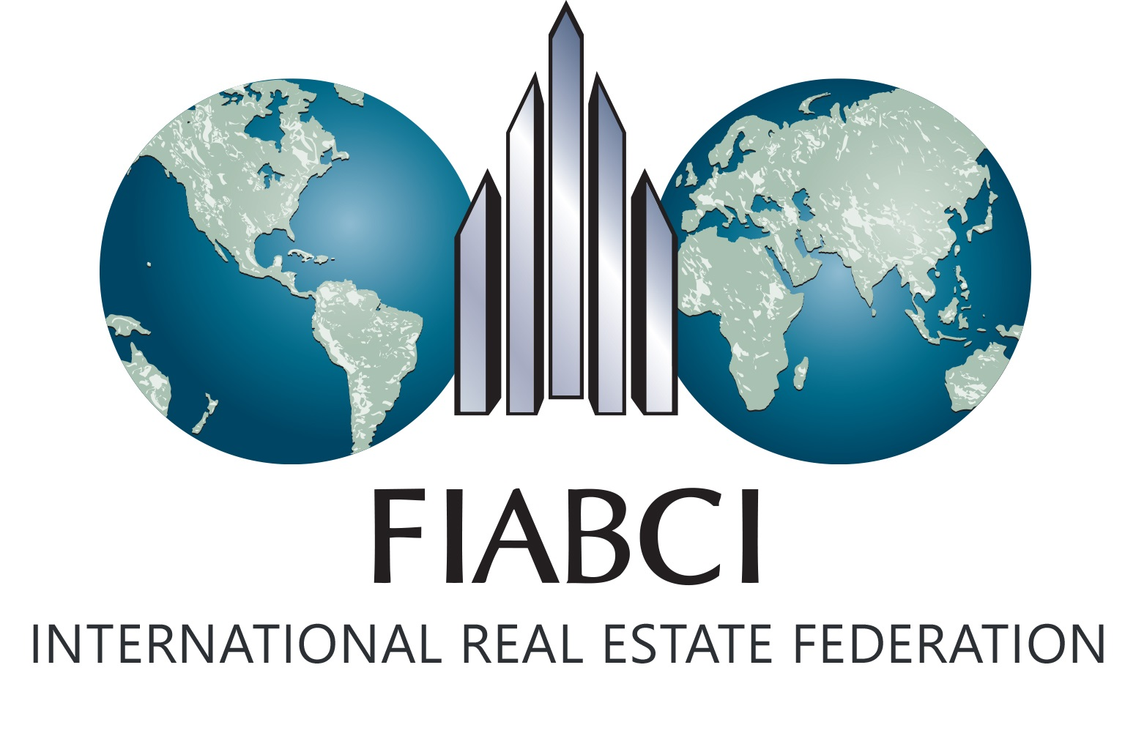
17 rue Dumont d'Urville
75116 Paris, France

Rubenstein Public Relations
Contact: Mitchell Breindel
212-805-3090; mbreindel@rubensteinpr.com

FOR IMMEDIATE RELEASE

FIABCI TO PRESENT GLOBAL SOLUTIONS FOR URBAN DEVELOPMENT AT UNITED NATIONS HABITAT III CONFERENCE IN QUITO, ECUADOR OCTOBER 18
International Real Estate Federation’s Proposal for Sustainable Real Estate Development to focus on the Implementation of a New Urban Agenda
Washington D.C. – October 13, 2016 – FIABCI, the International Real Estate Federation, a business network of real estate professionals worldwide with members in 65 countries, will be presenting global solutions for the future of urbanization and building sustainable cities at the UN Habitat III World Urban Campaign in Quito, Ecuador on October 18, 2016 at 4 pm (GMT-5). The announcement was made by Kirkor Ajderhanyan, World President of FIABCI.
FIABCI’s “The City We Need is Affordable” campaign will culminate in a parallel event to the UN Habitat III in Quito on October 18, at the JW Marriott Hotel Quito, Amazonas Ballroom. They will unveil several concrete solutions including the FIABCI Cloud Platform for assessing a city’s sustainability, a plan to create a global policy framework for sustainable real estate development, as well as a proposal for an affordable housing development project for the city of Quito. FIABCI will also launch a book featuring the winning entries in its contest for affordable housing solutions in technology, policy, architecture, building materials, public private partnerships, financing, and urban planning.
“The UN is forecasting extraordinary population growth and urbanization in the next 35 years, which offers a unique opportunity for the private sector to get involved to quickly increase the supply of affordable/workforce housing,” said Mr. Ajderhanyan. “FIABCI, as representative of the private real estate sector, and with a longstanding history of active cooperation with the United Nations, actively promotes the importance of transparent real estate markets for global economic growth and social and financial stability.”
“The New Urban Agenda will be the outcome document agreed upon at UN Habitat III and guide the efforts around innovative solutions for urban living at a critical time, and lay the groundwork for policies that will extend far into the future,” added Danielle Grossenbacher, Chair of FIABCI’s The City We Need is Affordable Campaign.
About FIABCI
FIABCI, the International Real Estate Federation, is a business network of real estate professionals worldwide that provides access and opportunity for professionals to gain knowledge, share information and conduct international business with each other. Kirkor Ajderhanyan is the current World President of FIABCI.

With members in 65 countries, including 100 professional associations, 65 academic institutions and 3,000 individual members from all professions of the real estate sector, FIABCI is the most representative organization of the real estate industry in the world and holds special consultative status with the Economic and Social Council (ECOSOC) of the United Nations. FIABCI members represent all real estate disciplines including brokerage, property management, valuation/appraisal, investment, development, consulting, legal, architecture, planning and insurance. Members work in all property sectors, including commercial, residential, luxury, retail, rural, resort and industrial. FIABCI's areas of focus include global networking, international business development, education and advocacy in the global real estate industry.

# # #

