"Proyecto Pregunta” or “Question Project” is a critical participatory device, aimed to intervene civic participation methodologies in order to question and open new types of community awareness and civic engagement. Activated as a tool for community engagement in public spaces and cultural institutions in Latin America and Europe, it is designed to foster the collective generation, visualization, and dissemination of public debates, through a dialogue-based site-specific participatory performance.

For Habitat III, the project will collect questions form neighbors and visitors at Plaza Foch (Saturday 15) on the afternoon, and in Plaza Mayor (Monday 17), Parque La Alameda (Tuesday 18), and Parque El Ejido (Thursday 20), form 11:00 to 19:00. These questions will address urban, political and social issues related with the goals of the conference from a citizen’s perspective.

The project is developed by Mil M2 - an arts collective based in Santiago - focused on the development of cultural institutions and devices for the collective generation of knowledge. Proyecto Pregunta, has toured a series of cities and in Chile, Spain, Brazil and Germany, fostering common debate and building and international archive of more that 10.000 questions.

For further information, please check
#proyectopregunta
instagram: @milm2stgo
facebook: mil metros cuadrados

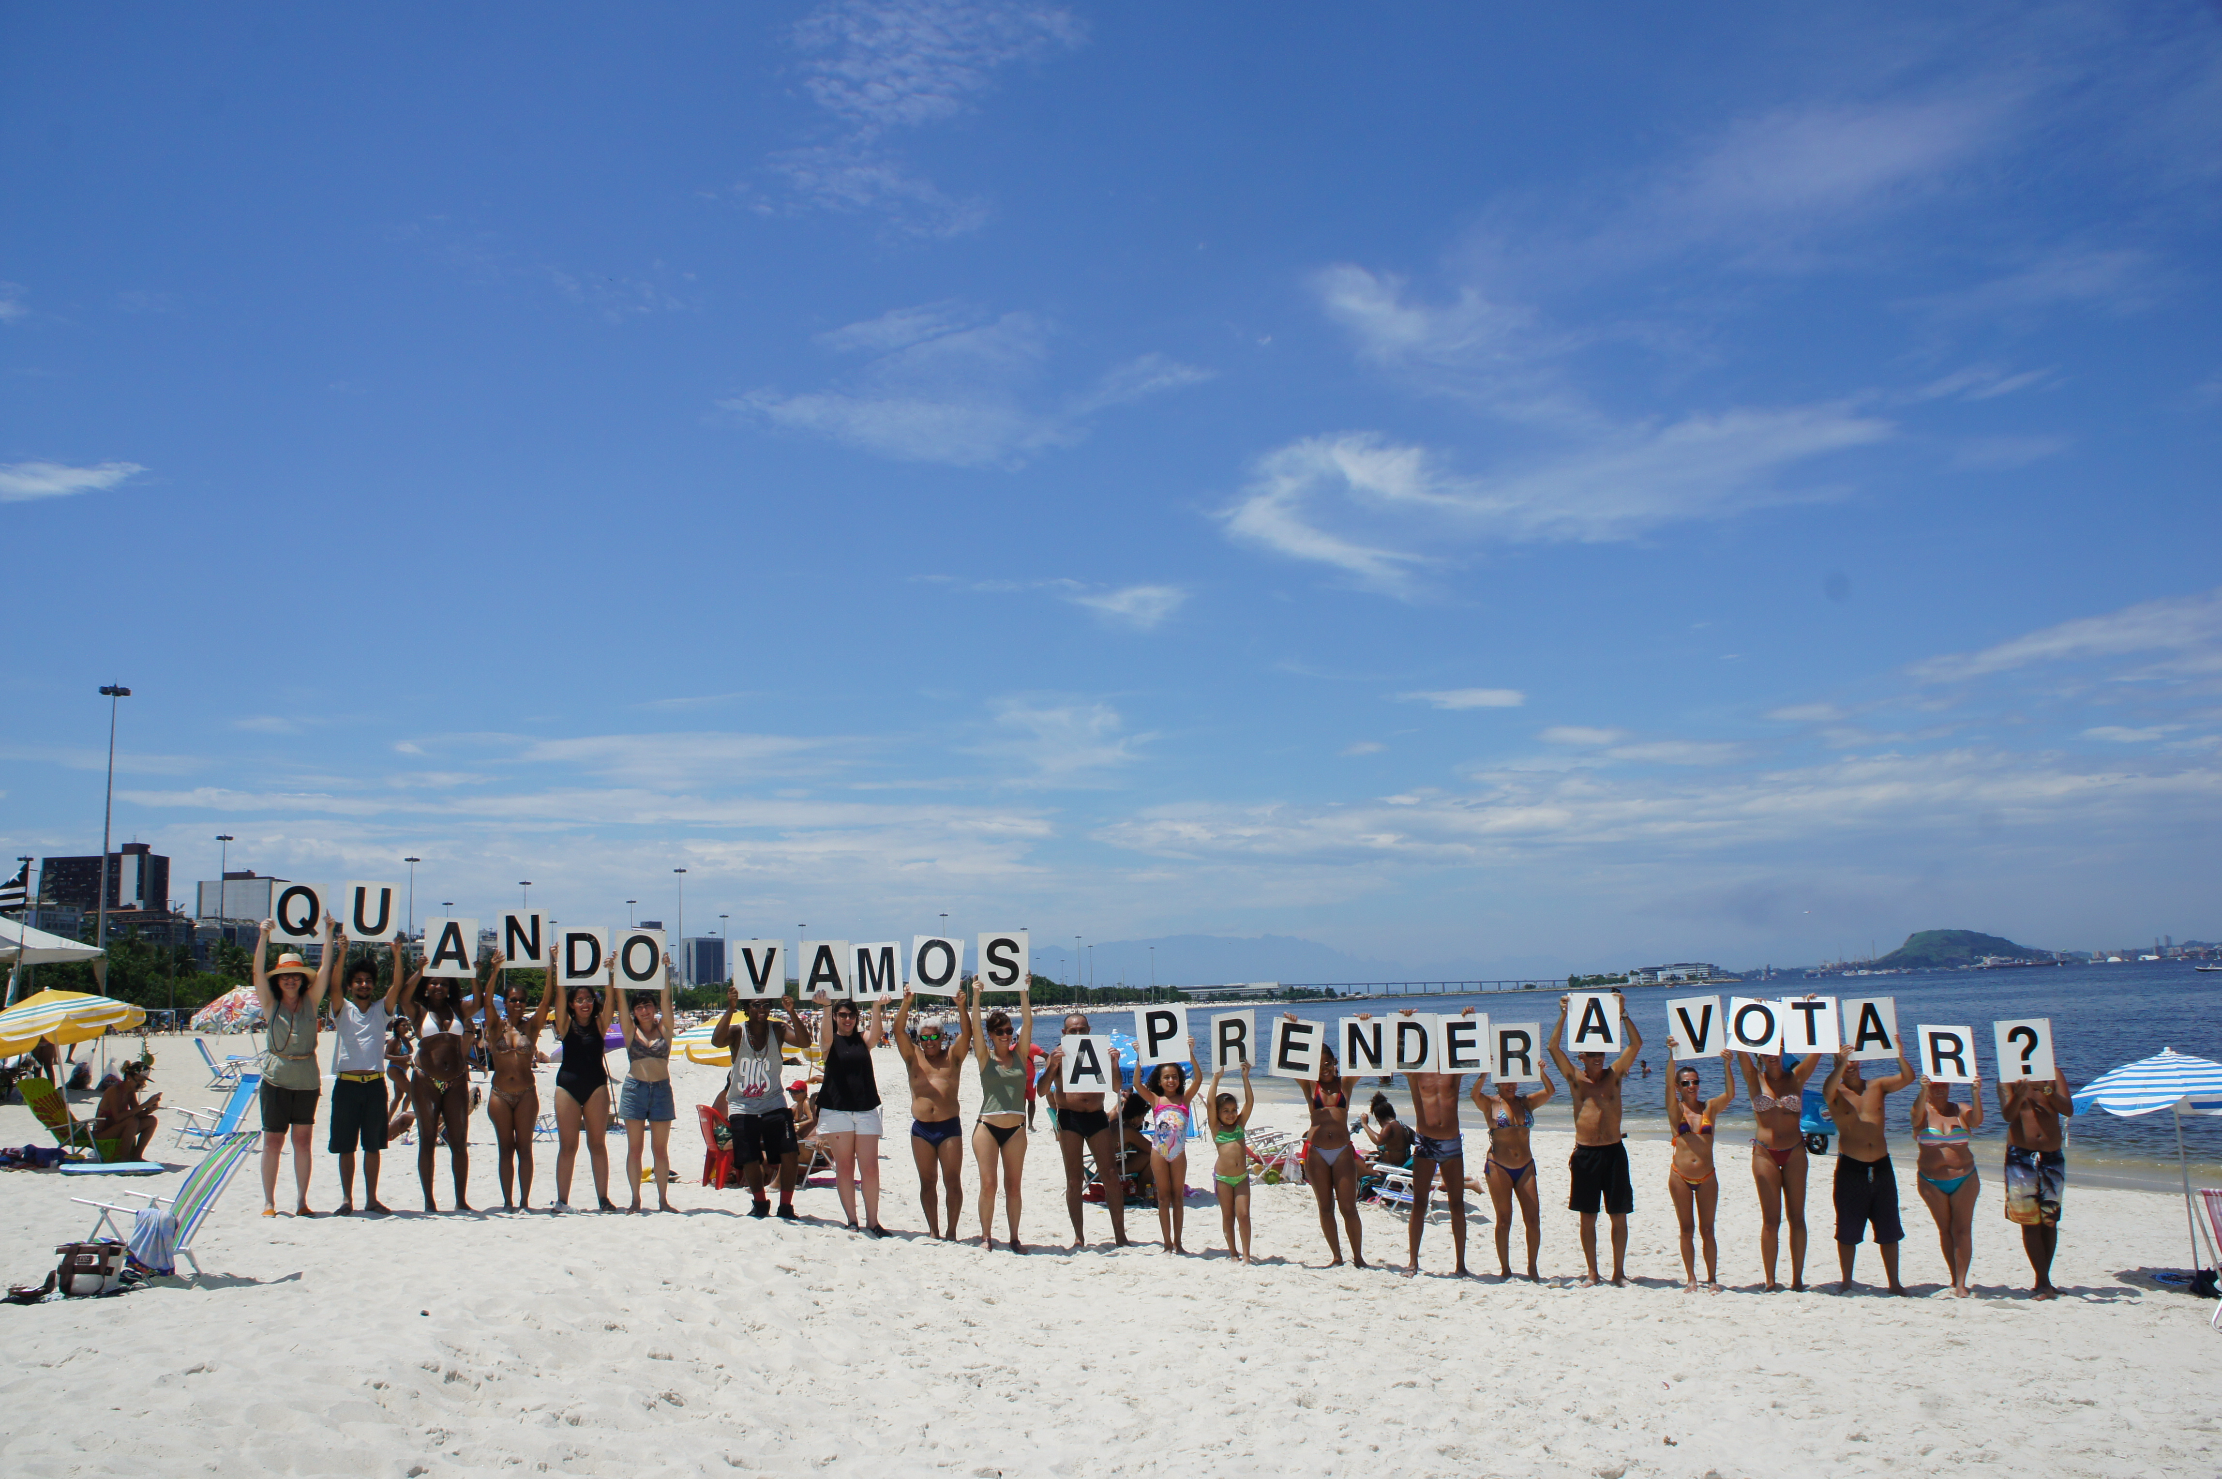
When are we going to learn how to vote? – Proyecto Pregunta- Rio de Janeiro, Brazil, December 2015

