PRESS RELEASE
For Immediate Release: 12-10-2016
Active and Accessible Cities: Cycling Delivers on the Global Goals and the New Urban Agenda
Room MR18 – October 20th – 2:00-4:00pm
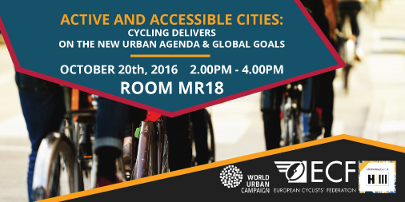
At the Habitat III conference in Quito, Ecuador, let’s talk about cycling!
There are many tools available to transform cities into more active and accessible cities; and cycling is one of them. The bicycle is so much more than transport and has already contributed to sustainable urban development, and can deliver significantly to the Global Goals and the New Urban Agenda. With this in mind, the European Cyclists’ Federation (ECF) and its co-organizers have created a Networking Event during Habitat III to bring together stakeholders from different sectors and backgrounds to discuss and agree upon how we can put into practice the outcomes of the New Urban Agenda in combination with the Sustainable Development Goals (Global Goals) for active and accessible cities through cycling promotion.
The event will start with an overview presentation by Secretary General of the European Cyclists’ Federation and the World Cycling Alliance on how cycling fits into the New Urban Agenda. Next Hyderabad Bicycling Club and NextBike GmbH will present an example of implementation and collaboration between civil society and business with their project of the bicycle share system for Hyderabad’s (India) new metro rail.
Then the tables turn to the audience to discuss cycling through four themes: HEALTH, CLIMATE, GENDER/AGE/ACCESSIBILITY, BEHAVIOUR CHANGE. With the results of these groups discussions, the event will end in a panel discussion with experts from HealthBridge (Canada), City of Belo Horizonte, (Brazil), Instituto Clima e Sociedade (Brazil), European Cyclists’ Federation / World Cycling Alliance (Belgium), and YoutHab (Ecuador) all on stage.
------- END -------
NOTES TO THE EDITOR
About the European Cyclists' Federation: With over 80 members across more than 40 countries, the European Cyclists’ Federation (ECF) unites cyclists’ associations from across the globe, giving them a voice on the international level. Our aim is to get more people cycling more often by influencing policy in favor of cycling.
www.ecf.com @EuCyclistsFed

About the World Cycling Alliance: The WCA, launched as an ECF initiative at the Velo-city 2014 conference in Adelaide, Australia, is a global network of non- governmental and civil society organizations with a substantial interest in promoting cycling. The main objective of the network is not only to advocate for cycling as a means of transport within international institutions – such as UN, OECD/ITF, World Bank- but also to promote and support the exchange of knowledge, expertise and co-operation of cycling associations and organizations worldwide. The WCA has currently 118 members from all continents.
@WCA_cycling

Co-organizers of the event:
- Hyderabad Bicycling Club
- Bike Anjo
- Transporte Ativo
- NextBike GmbH
- Laboratorio de Cambio Social

CONTACT IN QUITO
Zoé Kruchten
ECF Global Policies Coordinator
z.kruchten@ecf.com
+32 470 29 74 15

