Networking Event, 19 October 2016:
Public Space in the New Urban agenda: The Road To Implementation

A networking event with Ax:son Jonson Foundation and UN Habitat as hosts will take place on 19 October, from 2 p.m. - 4 p.m. in room MR11 at the venue of the Habitat III Conference, Casa de la Cultura Ecuatoriana "Benjamin Carrion".

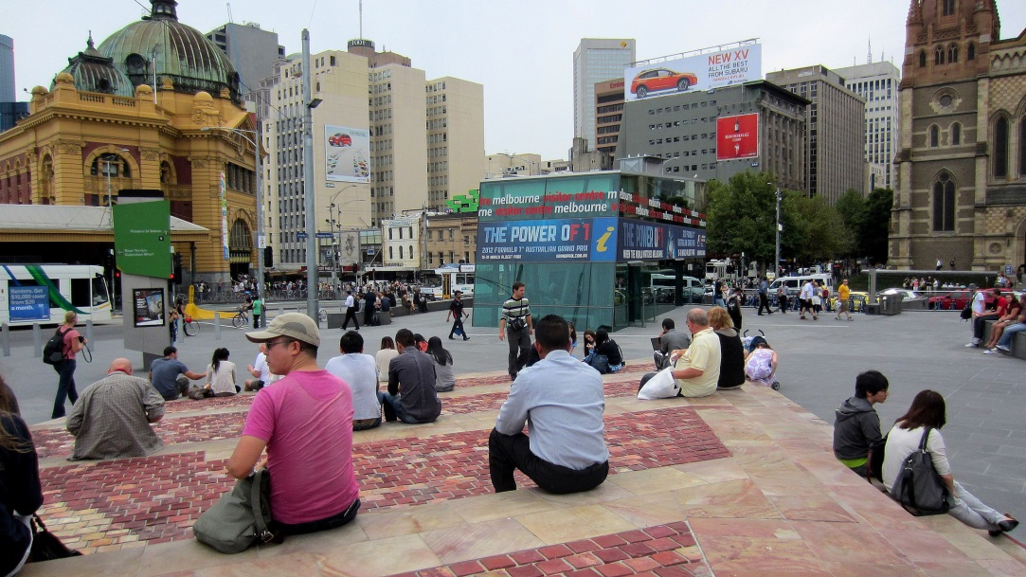

Panel: The Road to Implementation
Cecilia Martinez UN-Habitat
Raf Tuts UN-Habitat
Joanna Alimanestianu Council for European Urbanism
Doug Kelbaugh University of Michigan
Setha Low Public Space Research Group, CUNY
Moderated by Michael Mehaffy, Chair, Future of Places Research Network

Implementing the “Public Space Agenda”
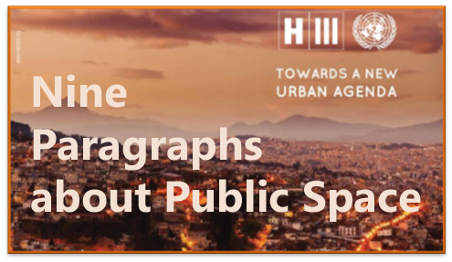

The New Urban Agenda, set to be approved at Habitat III, contains nine paragraphs that deal with the key role of public spaces as "drivers of social and economic development," "enhancing safety and security, favoring social and inter-generational interaction and the appreciation of diversity" as well as "promoting walkability and cycling towards improving health and well-being."
This central emphasis on public space accords with the findings of the Future of Places forum, a partnership of UN-Habitat, Project for Public Spaces, and the Ax:son Johnson Foundation, its NGO host. Over its four years of conferences and other gatherings, the initiative has brought together over 1,500 researchers, practitioners, officials and activists, representing more than 700 organizations, 275 cities and 100 countries from around the world.
Now that the New Urban Agenda is about to be granted final approval, the focus must turn to implementation.
This session will bring together members of national and local governments, UN agencies, research institutions, communities, NGOs, private sector companies, professionals and others, to identify and take forward the collaborations that will be needed to implement this vital "public space agenda." Following a panel discussion to frame the issues, participants will help to develop recommendations for implementation as follows:
- Identify key levers for action and transformational change;
- Identify the enabling tools and resources that will be required at global, national and local levels, to support implementation.
- Distill key recommendations for the implementation, on national, local and global levels;
- Develop key networks and partnerships to facilitate collaborative dialogue, exchange, cooperation and research among partners and local authorities in driving the New Urban Agenda forward into implementation.

Key Messages from the Future of Places:
The Future of Places Network has recognized that healthy and sustainable cities can only grow upon an essential connective matrix of public space, that is accessible, inclusive and safe, and that is adequate and well-structured. This, we believe, must be the urgent heart of the New Urban Agenda:
First, adequate, accessible public spaces are key to providing powerful economic benefits for cities, including lower-income populations. Public space can stimulate the small scale, local and informal economy, and play a key role in knowledge spillovers and broad-based economic development.
Second, well-structured public spaces play an essential role in public health and social well-being. They provide for social interaction, walking, exercise, recreation and psychological restoration, and they can improve neighborhood safety and security.
Third, well-connected public space systems are essential to ecological, resource-efficient and resilient urban development. They support much more efficient lifestyles within compact, mixed-use developments, that are complemented by renewable and ecological systems.

The following are key implementation requirements:
First, a city-wide approach is essential, assuring the form, function and connectivity of public spaces. City planning must provide a fine-grained, uninterrupted network of blocks and streets, and encourage buildings of mixed uses, ages and sizes, that are supportive of adjacent public spaces.
Second, a people-centered, participatory approach is needed by local agencies. Public, civic and private entities with differing capabilities and responsibilities must collaboratively share in the planning, design and maintenance of public space.
Third, public space and its edges must be of human scale. Appropriate shape, character and scale of the buildings that form the edges of public space are essential to overall connectivity and proper function.
Fourth, public space is made unique and meaningful through cultural and contextual elements that enrich local identity. Spaces should be place-based, adaptable and expressive of geography, climate, nature, culture and heritage, while accommodating public art and performances.
More broadly, there is an urgent need for shareable tools and knowledge to implement this public space agenda, and to make the necessary transformations of the current “operating system for growth”, including key economic incentives. Our network commits now to ongoing work toward that essential goal of the New Urban Agenda, up to and beyond Habitat III.

