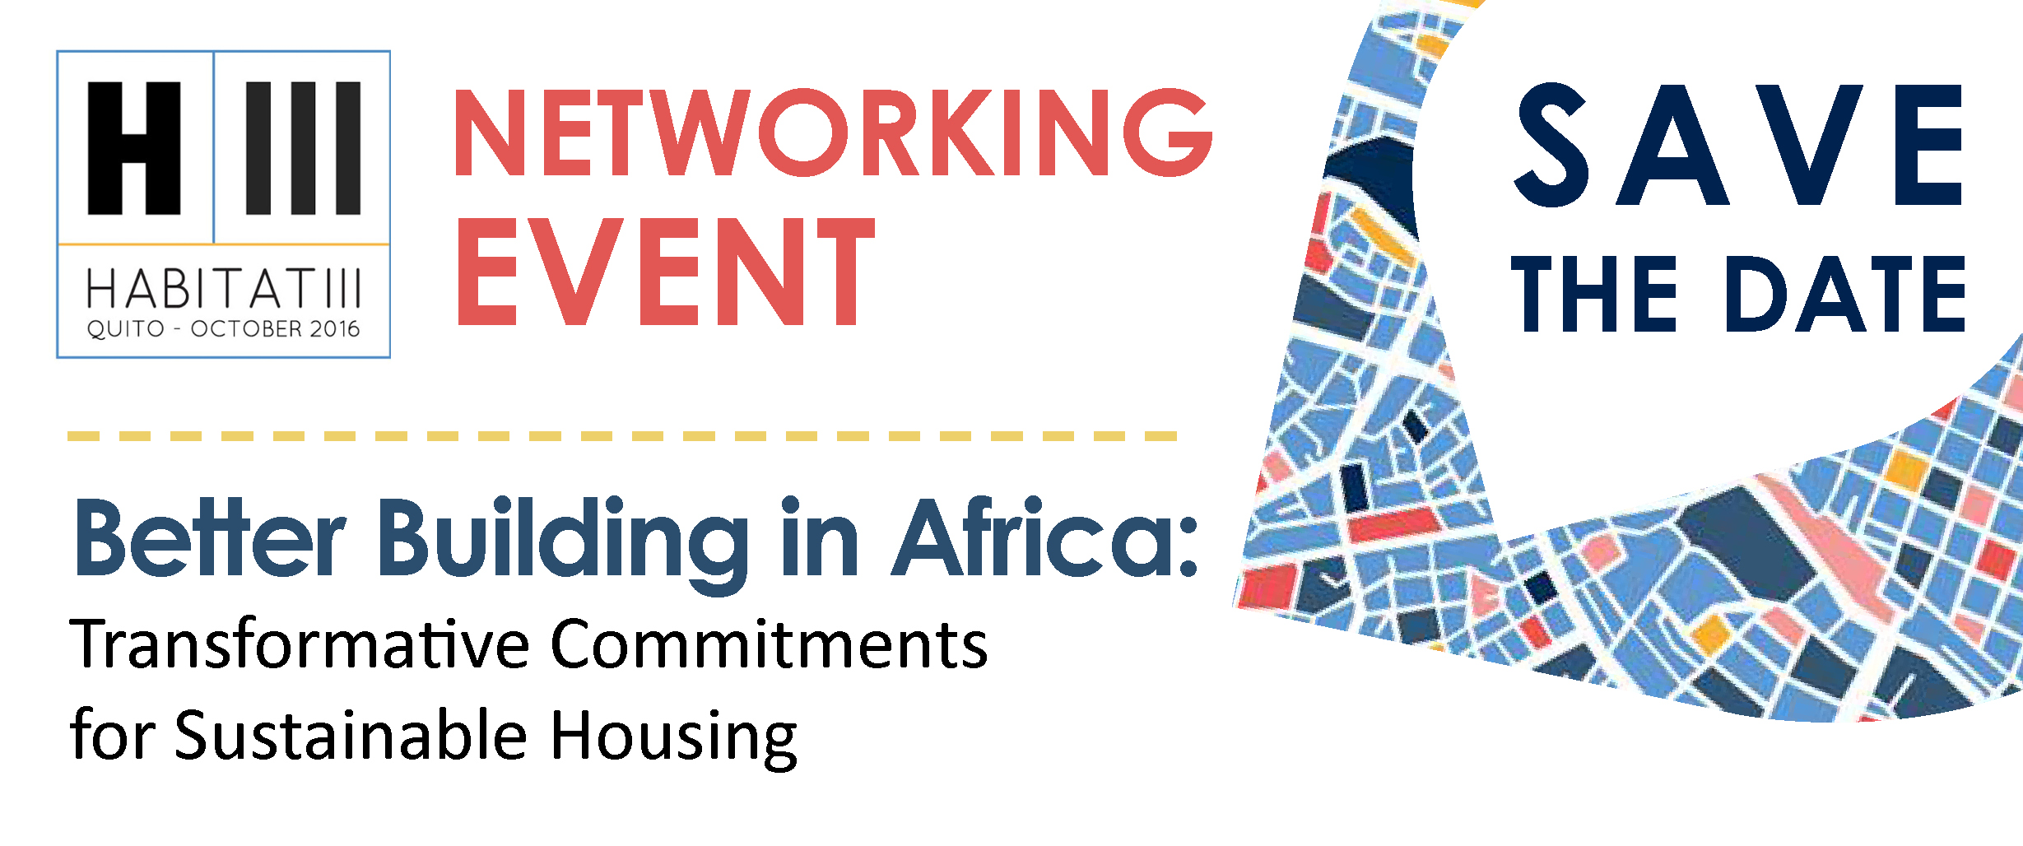

Stakeholders committed to sustainable building in Africa come together to present practical and replicable solutions for improved living conditions of the greater number.
Showcasing examples of bioclimatic buildings around the continent, multi-stakeholder alliances and a special partnership between a Ministry and an NGO in Ghana, this networking event seeks to create connections between all relevant actors to generate systemic change all along the building and housing value chains.
Thursday Oct. 20th, 2016 - 2:00-4:00pm / Room R10
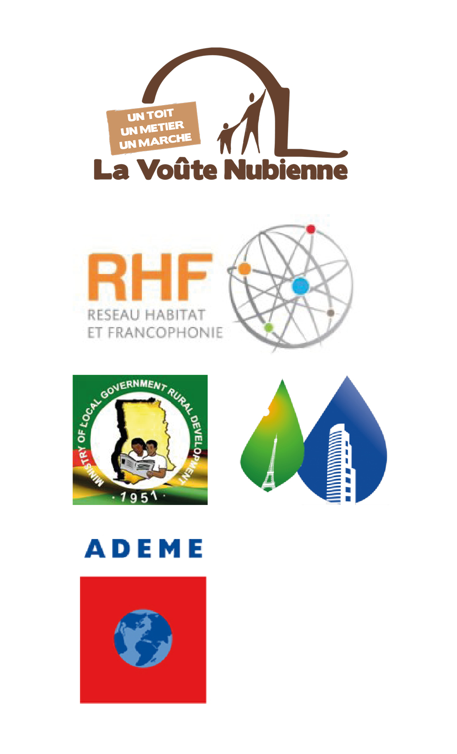
Casa de la Cultura Ecuatoriana

Speakers
Cécilia Rinaudo, the Nubian Vault Association
Yves-Laurent Sapoval, Global Alliance for Building
and Construction
Sylvanus Adzornu, Ministry of Local Government
and Rural Development, Ghana
Bernard Hoarau, Réseau Habitat et Francophonie
Amandine Crambes, French Agency for Environment
and Energy Management
Sarah Esinam Ziddah, Affordable Housing Network
Ghana

