The revival of brownfield locations in terms of sustainable development – example of the residential and commercial complex “Stepa Stepanović“ in Belgrade

Bojana Poledica
Sofija Tanasković

Abstract: As witnesses of the modern society we are aware of the importance of sustainable development for the prosperity of a country. The process of deindustrialization of the economy in the Republic of Serbia has left a number of consequences in space. Some of them are brownfield locations which regeneration could lead to encourage socio-economic and environmental development of the country. In according with the foregoing, the aim of this paper is to provide policies and guidelines to revive these areas. Methods of analysis and synthesis, research work and knowledge from domestic and foreign literature we have come to a conclusion about how is currently way of use brownfield locations, possible measures and solutions to revival a brownfield and spreading the positive effects on the surrounding area. Brownfield locations as insufficient used space have negative impact on environment, not only in economic, but also in the aesthetic, environmental and psychological sense. At these locations are often ruined and rusty abandoned facilities what are representing the environmental handicap and problem for environment. For this reason, their regeneration is one of the mechanisms to enhance environmental quality.
After the adoption of the Master plan for disposal of military property in June 2006th there is a new category of brownfield locations - locations who previously had a military purpose. On example of the residential and commercial complex “Stepa Stepanović“ in municipality Voždovac (Belgrade), we can clearly recognize successful revitalization of brownfield areas. The conversion of military land to residential and business complex has led to the resolution of issues "abandoned area". Caserne „4 July“, on whose territory now built „Stepa Stepanović“, was a socio-ecological unsustainable area. Construction of residential and commercial complex were resolved social housing, while at the same time provided an opportunity for economic development dominated by the tertiary sector. Infrastructure equipment of land, organizing of green space was created environmentally friendly environment. Accordingly, this example is represent how reviving brownfield can have a positive impact on the area in accordance with sustainable development.

Key words: brownfield, sustainable development, housing estate „Stepa Stepanović“, conversion.

TERM BROWNFIELD LOCATION
The most acceptable definition of the brownfield location is the definition proposed by the working group CLARINET which was later amended and according to the Europen Expert Network CABERNET. First definition is : ,,Brownfield locations that have been previously influenced by their users and the surrounding area, which are ignored or underutilized, which may have potential problems with lack of management, which are located mainly in developed urban areas and which require intervention to be returned to beneficial use”. Amended definition is: ,,Brownfield locations means areas that were under the influence of its users, which are ignored or underutilized, mainly located in developed urban areas, requiring the intervention to be returned to beneficial use, and may have problems with the current lack of maintenance”.
In many cities, brownfield locations make up a large part of built area. Assumed to have environmental burden and negative influence impact on wider environmental in economic, social, esthetic and psychological sense. Brownfields are property, legal, functionally and physically abandoned areas, which means there is no activity on them even though they are under someone’s property, that no rights to use or at the stage of bankruptcy, that are unresolved property issues or are abandoned by owners and left to jurisdiction of the city/municipality . They can be :
- industrial;
- military facilities and
- agricultural.
According to the Spatial Plan of the Republic of Serbia, brownfield is the land which was previously constructed and used, in the meantime due to economic-financial or other reasons were abandoned or unused.

CHARACTERISTIC AND ANALYSIS RESEARCH

Changing of social structure of the Republic of Serbia and abolition of military service 2011., has led to changes in the role of the army and the organizational structure of the state. Th decision, of the military facilities that are located in urban and attractive part of the city became the main in the brownfield’s classification. Serbian army decided in consultation with the Government of Serbia, to carry out the conversion of land and buildings to its assets that are no longer in operation and whose capacity is not necessary.
On the basis of the previous, Government of Serbia has signed an agreement on joint construction at the side of the barracks “Duke Stepa Stepanović” in Belgrade with Building Directorate of Serbia, which is enabled the construction of residential and commercial complex which is now located at the previous mentioned barracks, actually previous brownfield.
Barrack “Duke Stepa Stepanović” in the local community Kumodraž in the municipality Voždovac (City of Belgrade), occupied an area of 410187m^{2,} which are constructed buildings for accommodation of the soldiers. After the official termination of the barracks, security functioned until the date of handover of barracks complex to Building Directorate of Serbia 31.1.2011.

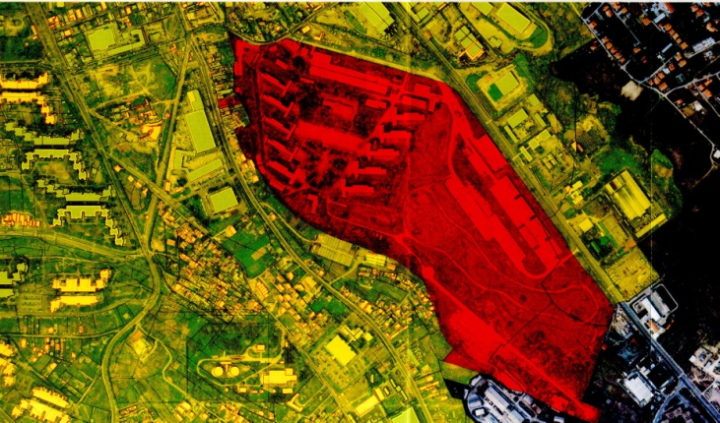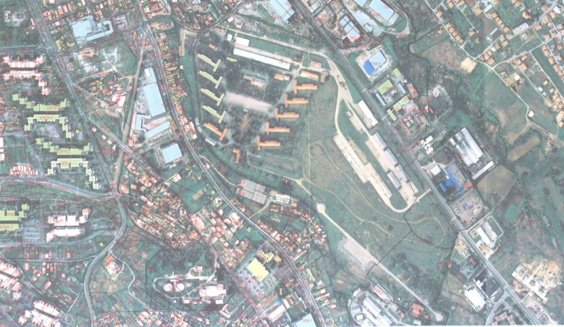
Picture 1. Ex barracks “Duke Stepa Stepanović” (Ministry of Defence - Military Construction Institute Belgrade, 2014).

Amending General urbanistic plan of Belgrade, barracks ,,Duke Stepa Stepanović“ is provided for housing. For this area has been done urban project which are defined by the following boundaries: Voždovački circuitous route on the north, Duke Street in the west and green spaces on the south. Territory of the project is far 6km southeast from the centre of the city Belgrade.

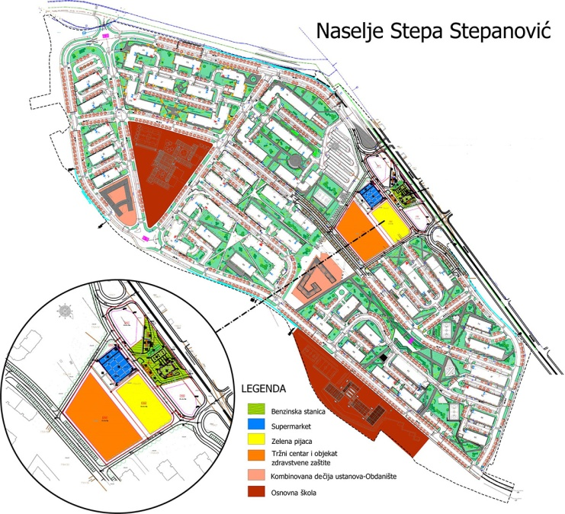
Picture 2. Settlement ,,Stepa Stepanović” (http://www.gds.co.rs/naseljess/kompleks.php)

The land under the project of conversion is determined for housing. Design space is performed at the highest level from the standpoint of public facilities, the availability and quality of life in the city. The revitalization of infrastructure systems and supplement the capacity is completed on this area, and that is contribute to a better quality lifestyle space users and the environment.
During the construction of residential complex was renovated a large percentage of existing green areas and set up a new plant. Today percentage of green space in the “Stepa Stepanović” is about 50% of the total area.
An example of the revitalization of the barracks "Stepa Stepanović", which was a socio-economic and environmentally unsustainable part of the city, is a good representative for a way how to reactivate and revive another brownfield locations. Some of the successful measures to revitalize that are applied in this case are, first of all, the conversion of military land, preparation of planning documents and the adoption of adequate and professional decisions on future space in accordance with sustainable development.

Measures that can be applied to revitalize a brownfield are:

- set up a good and responsibility legal framework;
- identification of the size and severity of the problem;
- informing the public;
- supporting investment and entrepreneurial activities on brownfield locations;
- solving property and legal issues;
- public-private partnerships;
- create a catalog of brownfield locations, with detailed information and analysis on the location.
Brownfield regeneration is a method that allows to achieve a balance between protection and development of environmental, social cohesion and creating new economic value. As one of the goals of sustainable development of this process can be viewed from three aspects - ecological, economic and social. The importance of ecological development is reflected in the fact that the regeneration of brownfield means improving the air quality in the city, the rational use of land and clearing of potentially contaminated land. The social importance is reflected through the creation of a sense of community, reducing population density in the city center, creating new jobs and the possibility of solving the problems of social housing. The development of entrepreneurship, attracting domestic and foreign investors, new jobs, a more favorable economic environment are some of the positive economic impact that brings brownfield revitalization.

SUMMARY

The exact number of brownfield sites in the territory of the Republic of Serbia has not been determined. Their recording and producing catalogs of local self-governments, establishing horizontal and vertical coordination at all levels of government, would create new opportunities for the launch of "dead" space, which would contribute to faster ecological and socio-economic development of local government units, and therefore the state. Revitalization of brownfield creates a positive ecological environment that improves the general condition of the environment and the aesthetic look that gives a feeling of comfort and positively affects the psychological state of the population.
The construction of settlements "Stepa Stepanović" created a viable space, equipped with infrastructure, aesthetically decorated, with a renewed and landscaped areas. Housing units have resolved the issue of housing, as well as within the complex population provided various facilities of parks, playgrounds, schools, kindergartens, to service shops (shops, pharmacies, bars).
If you look at the previous state of the location and the fact that the barracks "Stepa Stepanović", since it was not functional, represented the load space, it can be concluded that the signing of the residential complex was good and a crucial step towards the activation space, preservation and enhancement of the environment.
Complete work shows the importance of brownfield reactivation for the environment and sustainable development and provides justification for putting them on the place of the priority task of management at all levels. Striving to improve the economic development and ecological condition can be achieved through proper problem solving brownfield sites.

REFERENCES

Filipović, D., Petrović, Lj. (2014). Ekološka komponenta obnove degradiranih urbanih površina – primer industrije motora “21. maj” Rakovica u Beogradu. U Lokalna samouprava u planiranju i uređenju prostora i naselja, Zlatibor 4-6. aprila 2014 (str. 335-341). Beograd: Asocijacija prostornih planera Srbije i Geografski fakultet Univerziteta u Beogradu.
Damjanović, D. (2008). Oživljavanje braunfilda u Srbiji. Beograd: PALGO centar.
Ministry of Defence – Military Construction Institute Belgrade – Republic of Serbia - http://www.mod.gov.rs/
(2009). Izmene i dopune Generalnog plana Beograda 2021 – Faza 2 (Izmena i dopuna GP 2/2006). Beograd: Službeni list grada Beograda, br. 63/09.
(2010). Zakon o Prostornom planu Republike Srbije od 2010. do 2020. godine. Beograd: Službeni glasnik Republike Srbije, br. 88/10.
Institute of Transportation - CIP - www.sicip.co.rs
The Building Directorate of Serbia - www.gds.co.rs

Bojana Poledica – dipl. spatial planer; e-mail: bojanapda@gmail.com
Sofija Tanasković – student of final year undergraduate studies of spatial planning ; Geography , University of Belgrade; e-mail: sofijca23@gmail.com
CLARINET (Contaminated Land Rehabilitation Network for Enviromental Technologies)
CABERNET (Concerted Action on Brownfield and Economic Regeneration Network)

