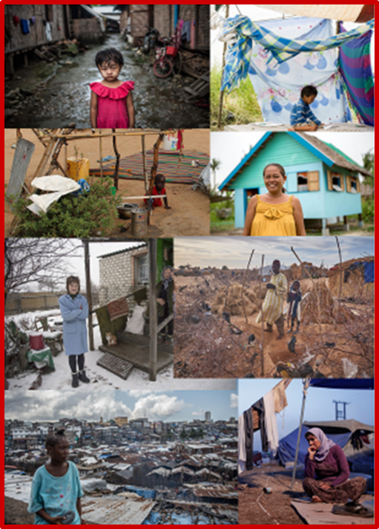
Press release
AT THE HABITAT III CONFERENCE IN QUITO CARITAS DEFENDS
"A COMMON HOME WHERE EVERYONE CAN LIVE DECENTLY”
Caritas Internationalis, in collaboration with Caritas Ecuador and Caritas Spain, convenes
a side event in Quito on 17 October, coinciding with the opening of the Third United Nations
Conference on Housing and Sustainable Urban Development (Habitat III)
13 October 2016 - Coinciding with the opening of the sessions of the Third United Nations Conference on Housing and Sustainable Urban Development (Habitat III) to be held in Quito, on 17 February the Caritas network has organised a side event in the Ecuadorian capital on the theme “A common home where everyone can live decently".
Taking into the account the 2030 Agenda for Sustainable Development and the agreement that no one should be left behind regarding the right to have a decent home, this event will seek to deal with different proposals relating to the provision of adequate housing to everyone, building public spaces for decent living, and the promotion of inclusive, fair and equitable cities for all.
Intense preparatory process in Geneva, Barcelona and New York
This event is the culmination of the intense preparatory process implemented by Caritas Internationalis in recent months to agree a common position for the entire international network ahead of the Habitat III Conference in Quito, which was convened in December 2014 by the General Assembly of the United Nations. This has been the objective of the side events led by the Caritas network in recent months, such as the one held in March on the occasion of the 31st Session of the United Nations Human Rights Council in Geneva; the event organised last April in connection with the Habitat III Thematic Meeting on Public Space in Barcelona; and the event convened in June by the Permanent Mission of Ecuador at the Headquarters of the United Nations in New York.
Adequate and decent housing
For Caritas, international legislation on Human Rights offers a valuable contribution to the current debate regarding the design, development and implementation of simple and open public spaces, as well as achievement of adequate and decent housing for citizens. Municipalities and local governments are able to provide their citizens with full access to civil, political, social, economic, cultural and environmental rights when they duly guarantee Human Rights standards of accessibility, affordability, habitability, availability and quality of public spaces and housing.

In her 2015 Annual Report for the General Assembly of the United Nations, the UN Special Rapporteur on the right to adequate housing presented reflections and key recommendations on the central importance of the right to adequate housing, which contributed to the proposal for a New Urban Agenda that will be discussed at the Quito Conference from a Human Rights perspective. This report identifies five fundamental priorities:
- social exclusion: stigmatisation in the area of housing
- migration
- vulnerable groups
- land and inequality
- informal settlements.
Moreover, the Special Rapporteur emphasised the importance of connecting the New Urban Agenda with the Human Rights Framework in order to promote urban models and housing based on people's needs and dignity.
Caritas upholds the position that the Human Right to the city and adequate housing should be at the heart of the New Urban Agenda. It is a vital principle for rethinking cities and housing via a holistic approach that promotes social justice, integral human development, full enjoyment of Human Rights, and the participation and inclusion of all citizens, public authorities and local communities, especially vulnerable and excluded groups and above all indigenous populations.
This will be the content dealt with at the side event held on 17 October at the Benjamín Carrión Casa de la Cultura Ecuatoriana in Quito, which has been organised by Caritas Internationalis with the support of Caritas Ecuador and Caritas Spain. The event will be inaugurated by Msgr Bernardito C. Auza, permanent observer of the Holy See to the United Nations in New York and to the Organization of American States, and will be moderated by Joan Uribe from FEANTSA. The speakers are Leilani Farha, the UN Special Rapporteur on the right to adequate housing; Mauricio López, executive secretary of Caritas Ecuador; and Sonia Olea Ferreras, an expert from Caritas Spain and Caritas Internationalis.

Caritas Internationalis position paper for Habitat III:
“A common home where everyone can live decently”.

The Habitat III Conference
The United Nations has convened the Third United Nations Conference on Housing and Sustainable Urban Development (Habitat III), which will take place in Quito from 17 to 20 October 2016. This conference, which is held every 20 years, brings together urban actors, governments, local authorities, civil society, the private sector and academic institutions at a first-rate international event, aimed at debating the challenges of urbanisation on a global scale and attempting to seek solutions and spot opportunities in the implementation of the so-called Sustainable Development Goals. It is also a forum to review the policies that affect the future of cities, with a view to generating a New Urban Agenda for the 21st century.

Its objective is to strengthen the global commitment to sustainable development and focus on implementation of a New Urban Agenda, based on everything that has occurred since the Agenda arising from the previous conference (Habitat II). Therefore, it tries to achieve a renewed political commitment to sustainable urban development, evaluate achievements so far, deal with poverty, and identify and tackle new and emerging challenges. The conference will give rise to a concise document, with a vision for the future and oriented towards results.
The first conference, Habitat I, was held in Vancouver, Canada, in 1976. Twenty years later, Habitat II was hosted in Istanbul.
For further information: http://unhabitat.org/habitat-iii/

Caritas press contact:
(Rome) Michelle Hough: Tel. ………………………. hough@caritas.va
(Quito) Maria Paula Ortega: Tel. …………………….. mortega@caritasecuador.org
(Madrid) Ángel Arriví: Tel. …………………………. aarrivi.ssgg@caritas.es

