Dear Habitat III Participants,

You are cordially invited to attend the Habitat III Children and Youth Assembly, one of four stakeholder assemblies occurring as part of the UN Conference on Housing and Sustainable Urban Development!

The details are as follows:
- Date: Saturday 15th October, 2016
- Time: 9.00am - 5.30pm
- Venue: Teatro Nacional, Casa de la Cultura Ecuatoriana, Quito, Ecuador
- Eligibility: Open to ALL stakeholders registered for the Habitat III Conference!
The Children and Youth Assembly is a one-day inter-generational and inter-stakeholder forum which aims to provide a platform for young people to share knowledge, showcase solutions, and develop partnerships to make cities and human settlements more equitable, inclusive, safe, resilient, and sustainable. The event aims to change the perception of the role of young people in shaping sustainable urban development, and to explore opportunities for them to play meaningful roles in the implementation, follow up, and review of the New Urban Agenda.
The Assembly will consist of plenary sessions, roundtables, and break-out sessions for group discussion and training. Speakers will come from diverse backgrounds, including UN Agencies (UN Habitat, UNEP), local authorities (mayors), international NGOs (World Vision, Habitat for Humanity, IFRC), academia (The Chinese University of Hong Kong), philanthropists (Ford Foundation) and youth-led organisations (UN MGCY, Water Youth Network, SDSN-Youth).
Participation in the Assembly will be split into two sections: one for child participants (under 16 years old) and the other for youth and other stakeholders. The “Children’s Section” will focus on urban issues and solutions impacting urban children, and will feature art and design, technology, and debate. The “Youth and Other Stakeholders Section” will divide into three streams: Science, Technology and Innovation, Children and Youth in the New Urban Agenda, and the Stakeholder Stream which will enable a diverse range of youth activists, young scientists, and urban experts to network, exchange ideas, and to develop partnerships toward the implementation of the New Urban Agenda.
Ultimately, this Assembly will highlight how -- as leaders of today and tomorrow -- young people should be empowered, included, and recognized as agents of change in fostering a more sustainable urban future for all. The key recommendations and outputs of the Assembly will inform a “Children’s Charter” and “Quito Youth Commitments,” to be shared at the Habitat III Conference.
All stakeholders will be most welcome to come and participate in the “Youth and Others Section” of the Assembly. The brief programme can be viewed below and more information can be accessed at www.urbandevelopmentyouth.org/cyassembly.
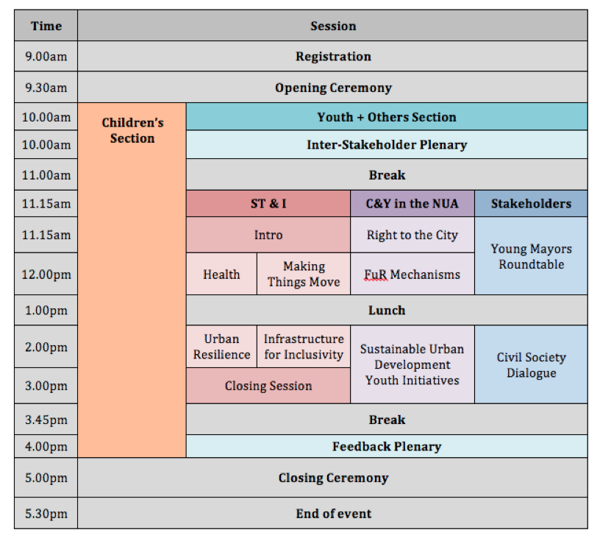
Overall, we hope you will join us for what will be a stimulating, exciting and energising event!

