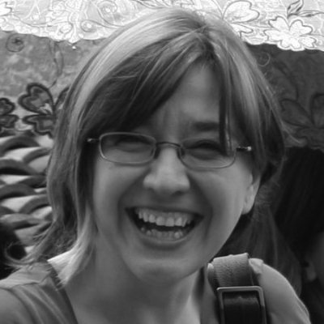

**Name: Ana B. Moreno**

**Title: Habitat III Coordinator**

**Event: High-level Round Table: Leave no one behind**

**Bio:** Ana B. Moreno is a graduate in Social and Cultural Anthropology and Journalism, both degrees by the Autonomous University of Barcelona. She also has a Postgraduate Diploma on Olympic Studies by the International Olympic Academy. Moreno was appointed as Habitat III Secretariat Coordinator in July 2014 and has coordinated the last two sessions of the World Urban Forum in Naples (September 2012) and in Medellin (April 2014). She started to work in UN-Habitat as Spokesperson in May 2011 and Advocacy, Outreach and Communications Coordinator in January 2012.

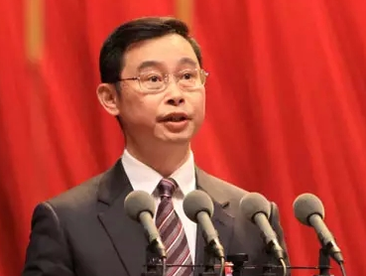

**Name: Excellency Wen Guohui**

**Title: Mayor of Guangzhou**

**Event: Plenary Session 1**

**Bio:** Wen Guohui is the current mayor of Guangzhou in the People's Republic of China. Wen was born in Jiexi County, Guangdong. He joined the Communist Party of China in 1984 and entered South China University of Technology in 1987. In 2001 he severed as deputy director of Economic and Trading Committee of Guangdong and director of the State Assets Committee of Guangdong in 2009. Wen was elected the CPC Secretary of Shanwei and Chairman of the Standing Committee of the Shanwei People's Congress. In 2015 he became the Vice-Governor of Guangdong.On 26 January 2016, Wen Guohui was elected the Mayor of Guangzhou.

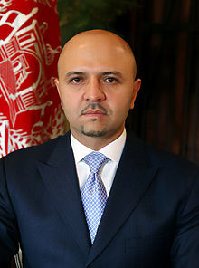

**Name: H.E. Sadat Mansoor Naderi**

**Title: Minister, Minister of Urban Development and Housing**

**Event: Special Session- Housing**

**Bio:** H.E. Sadat Mansoor Naderi is a renowned politician, business man and minister of the Government of Afghanistan.Naderi’s family has a political background. His father, Sayed Mansur Naderi a Member of Afghan Parliament. His younger sister Farkhunda Zahra Naderi, as well as his cousin, Dawood Naderi are also serving Afghan Parliamentarians.

On April 18, 2015, Sadat Naderi was elected as the Minister of Urban Development and Housing. He obtained 202 votes of confidence out of 239 from the Afghan parliamentary assembly. This result has been the highest vote achieved by any Minister nominee since the Afghan nation’s 2004 constitution was adopted. On April 22, 2015, Honourable Minister Sadat Naderi assumed Office.



**Name: Judith A. Oginga**

**Title: Urban Planner**

**Events: Urban Talks**

**Bio:** Judith A. Oginga is a graduate urban planner from the University of Nairobi. She has worked as a research assistant at the Centre for Urban Research and Innovations (CURI) from September 2011 where she gained meaningful experience in slum upgrading projects, community mobilization and research methods. Between January 2015 and December 2015, she worked as a junior planner with the University of Nairobi and the County Government of Isiolo, Kenya to formulate a county plan for the ASAL Region of Kenya. Currently she is a part-time assistant planner with Gitutho Architects and Planners, a well renown planning firm in Kenya.



**Name: Bingqing Hu**

**Title: Consultant- World Urban Campaign**

**Event: Urban Futures- The role of Media in Building Better Cities**

**Bio:** Bingqing Hu has been working with the World Urban Campaign since early 2016. She has a background in finance and economics with expansive experience in advocacy and communication. Hu has played a major role in supporting the “City We Need” campaign which is a global campaign championing the themes of urbanization using graphic images drawn on hands. She believes that the battle for sustainable urbanization will be won or lost in our cities.

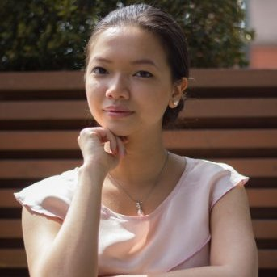

**Name: Nhusha Vu**

**Title: Consultant- United Nations**

**Event: High-level Round Table: Urban Inclusion and Prosperity**

**Bio:** Ms. Nhusha Vu is a consultant with the Habitat III Secretariat, Programme Support. She is a published co-author of three books titled ‘Banning street trade in Hanoi Law: life before and after’, ‘Sociology of Urban Space: the changes of the urban space using the example of Hanoi's city center’ and ‘The transformation of the social space: the history of a street as a mirror of social changes’. In 2014, prior to joining the UN, she contributed significantly to a research project on the land budgeting process in the Greater Golden Horseshoe for Neptis Foundation.



**Name: Norra O. Aloo**

**Title: Environmental Scientist**

**Event: Research and Academia Round Tables**

**Bio:** Norra O. Aloo is a student of environmental science at the University of Nairobi. She has keen interest in environmental issues and the actualization of the Sustainable Development Goals (SDGs) recently adopted by the United Nations member states. She encourages the use of non-motorized mobility options to protect the air quality of cities. She has been a student member of the Kenya Model United Nations since 2014.



**Name: Catrin Wallace**

**Title: Intern**

**Event: Urban Talks**

**Bio:** Catrin has a Law degree from Aberystwyth University and is a graduate in International Development Law and Human Rights (LLM) from the University of Warwick. She has previously worked as a researcher and writer for a legal directory in London.