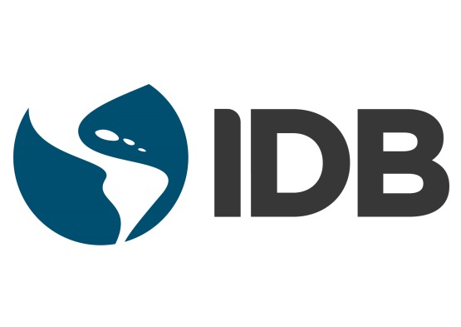

PRESS RELEASE

October 14, 2016

IDB President, experts to talk to members of media accredited to the Habitat III Conference in Quito, Ecuador

Habitat, the main global conference on Housing and Sustainable Urban Development, is being held for the first time in Latin America
The Inter-American Development Bank (IDB) will have a strong presence in the Habitat III Conference to be held in Quito, Ecuador, Oct. 17-20, 2016. During the conference, IDB experts will discuss the main challenges that Latin American cities will be facing in coming decades from an environmental and fiscal sustainability perspective, as well as mobility, water and sanitation and energy issues.
As part of the agenda, the IDB will hold two side events open to accredited media:
There can be no urban agenda without safe mobility
Monday, Oct. 17, 9:30 - 10:30 a.m., Urban Future Room, Casa de la Cultura Ecuatoriana
This event will discuss the importance of road safety and its relation to public transportation policies, urban planning and people-centered transportation. It will also present the winners of the “Gobernarte - Premio Eduardo Campos” award in the category of innovating cities on road safety improvement issues.
Speakers:
- Moderator: Luis Alberto Moreno, President, Inter-American Development Bank
- Jean Todt, President, International Automobile Federation (FIA)
- Gina Tambini, Ecuador’s Representative to the Pan-American Health Organization/World Health Organization (PAHO/WHO)
- Christian Friis Bach, Executive Secretary, the United Nations Economic Commission for Europe (UNECE)
- Jeanne Picard, President, Ibero-American Federation of Road Violence Victims Associations
The city of the future from a citizen’s perspective
Monday, Oct. 17, 2:00 - 4:00 p.m., Room R7, Casa de la Cultura Ecuatoriana
What will the cities of the future look like? At this event, renowned public sector leaders will explore how technological advances will change future city governance and government-citizens interaction. They will also analyze the urban infrastructure financing and climate change challenges.
Speakers:
- Martin O’Malley, Former Governor of Maryland, USA
- Libby Schaaf, Mayor of Oakland, California
- Sergio Fajardo, Former Governor of Antioquia, Colombia
- Horacio Rodriguez Larreta, Head of Government, Buenos Aires City, Argentina
- Michael Berkowitz, President, 100 Resilient Cities, USA
- Mónica Araya, Founder and Executive Director, Nivela, Costa Rica
- Paulina Saball Astaburuaga, Minister of Housing & Urbanism, Chile
- Sergio Galilea Ocón, Undersecretary of Public Works of Chile
Informal meeting of IBD President Luis Alberto Moreno with members of accredited media
The meeting will take place Monday, Oct. 17, 11:30 a.m. at the IDB stand located in the Habitat III site outside the National Assembly, area F #152.
IDB experts available for interviews
The IDB stand will also host a series of live talks where innovation and urban development experts will share ideas that will transform Latin American cities in decades to come. Following the live talks listed below, the specialists will be available to interested media.
Monday, Oct. 17
11:00 - 11:30 a.m. Sustainable cities' main planning challenges.
- Luis Alberto Moreno, IDB President
- Horacio Rodríguez Larreta, Chief of State, Buenos Aires, Argentina
Tuesday, Oct. 18
11:00 - 11:30 a.m. Urban Management in Latin American Cities
- Carolina Barco, Senior Advisor, Housing and Urban Development Division, IDB
- Janette Sadik-Khan, Principal, Bloomberg Associates
- Libby Schaaf, Mayor of Oakland, California
4:30 - 5:00 p.m. Urban infrastructure financing in Latin America and the Caribbean
- Ellis Juan, Division Chief, Urban Development and Housing Division, IDB
- Luis Fernando Arboleda, President, Findeter
- Abraham Zamora, General Director, Banobras
Wednesday, Oct. 19
12:00 - 12:30 p.m. Climate change and the new urban agenda
- Juan Pablo Bonilla, Manager, Climate Change and Sustainable Development Sector, IDB
- Mónica Araya, Executive Director, Nivela
Thursday, Oct. 20
11:00 - 11:30 a.m. Today’s children are tomorrow’s citizens: why the quality of daycare is important.
- Julia Johannsen, Senior Social Protection Specialist, IDB
- Juan Ponce, Director, FLACSO Ecuador
Members of the media interested in covering the event or arranging interviews must send an email to Andrea Durango: apdurango@iadb.org or Andreina Seijas: andreinas@iadb.org
What: Habitat III Conference
Where: IDB stand located in the Habitat III site outside the National Assembly, area G #152.
When: Oct. 17-20, 2016
For more information visit www.bid-habitat3.com
About us
The Inter-American Development Bank is a leading source of long-term financing for economic, social and institutional projects in Latin America and the Caribbean. Besides loans, grants and guarantees, the IDB conducts cutting-edge research to offer innovative and sustainable solutions to our region’s most pressing challenges. Founded in 1959 to help accelerate progress in its developing member countries, the IDB continues to work every day to improve lives.

