IRD and Ñan launch new issue for Habitat III dedicated to
“Ecuador: Laboratory for the world”

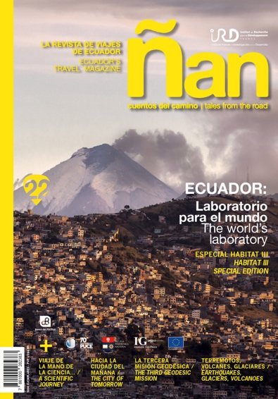

The French government agency, Institut de Recherche pour le Développement (IRD, Research Institute for Development), and Ecuador travel magazine, Ñan, have published a special issue that tells the story of the science that takes place in "Ecuador: Laboratory for the World."

Ever since the first Geodesic Mission of the 18th century, Ecuador has been an object of fascination for scientists. Investigations by the first European mission resulted in later establishment of a universal measurement unit (the metre); the discovery of the properties of quinine to treat malaria and the properties of rubber, a key element of the industrial revolution.

Ecuador’s natural bounty, with its microclimates, altitudinal ranges and diversity of flora and fauna, besides being a magnet for international visitors, remains a crucible of scientific discoveries.

In the field of seismology, for example, the information analyzed by geophysicists after the April earthquake helps to better understand the behavior of tectonic plates across the world, to better predict earthquakes and their magnitudes. In the field of volcanology, the recent activity of the Cotopaxi volcano is a window onto the geological movement of the Andes.

The 114-page magazine is a visual and literary tour-de-force of the country. Through a number of chronicles, the publication brings to life the beauty of Ecuadorian landscapes and how they have proved an inspiration for scientists worldwide. Through the pages, we get to know the scientists, learn about their ambitions and dreams, and share their daily lives out in the field.

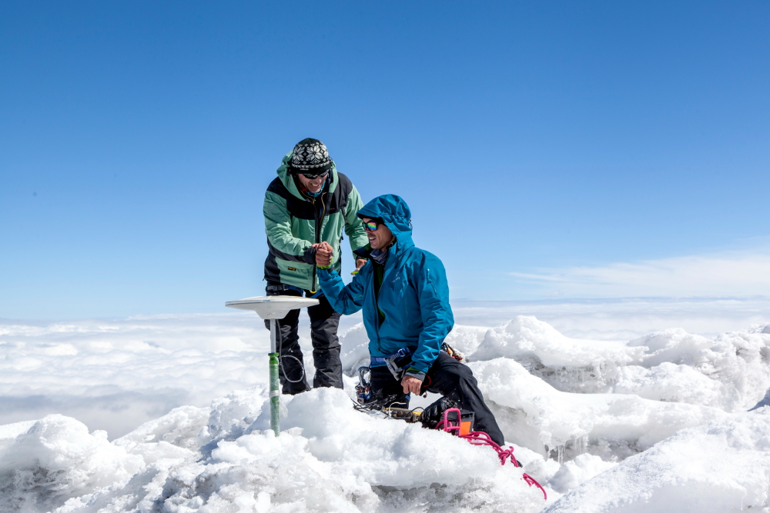

The magazine includes coverage of the ascent of Chimborazo Volcano in February this year, an expedition which confirmed the height of the summit as the closest point to the sun that exists on our planet.

"This edition of Ñan is an example of the historically close collaboration between France and Ecuador," explains Olivier Dangles, IRD representative for Ecuador. "We have created a new vision of how different teams and institutions can collaborate together in scientific research, and through their projects, conclusions and recommendations, build cities and regions that are safer for all."

Published to be distributed free during the Habitat III event in Quito, and to be downloaded free for tablet formats, Ñan magazine # 22 is a valuable contribution to the issues to be discussed in Quito.

"For our team to being able to illustrate and recount the stories of science and scientists found across our beautiful country represents a milestone for us. We hope readers will fall in love even more deeply with Ecuador, but this time through the eyes of science," says the magazine’s Director, Cristina Guerrero.

Institutions such as the IRD, the Catholic University of Ecuador (PUCE), the Geophysical Institute of the National Polytechnic School and the European Union have collaborated in the creation of this important publication.

In addition to the printed and digital magazine, the IRD and Nan have created a special exhibition in the Mariscal Sucre International Airport of Quito, in collaboration with the airport’s concessionaire, Quiport. The exhibition will be displayed in the departures hall and domestic departures terminal. In the ​​international departure terminal, the exhibition will be accompanied by two interactive screens with information, magazine articles, maps, image galleries and videos.

To accompany the magazine and the Habitat III event, the Ñan team has created four special videos: The ascent of Chimborazo; Volcanology in Cotopaxi; The post-earthquake journey to Manabi by scientists; and a video on issues related to Habitat III.

The magazine will be launched officially on Monday, October 17th, 2:15pm – European Union Pavilion - Stand #104 Expo Habitat.

To download the digital magazine for tablets, read more articles and view the videos, visit: www.nanmagazine.com

More materials for the press:
https://www.dropbox.com/sh/7kov17wmrxc9kn7/AAA2eZUWxH3oId9lAa4_5f09a?dl=0

Contacts:
Dominic Hamilton, Ñan
dhamilton@nanmagazine.com
+593 (0)995 618 317
+593 (02) 322-7464

Kabil Zerouali, IRD
kabil.zerouali@ird.fr
+593 (02) 250 3944
+593 (0)9 98 17 2004

The Research Institute for Development (IRD) is a French research organization. It is both original and unique in the European research development world. Emphasizing an inter-disciplinary approach, IRD projects span more than 65 years researching the relationship between humans and their environment in Africa, the Mediterranean, Latin America, Asia and the French tropical overseas territories. Research, training and innovation are intended to contribute to the social, economic and cultural development of developing countries.
Since 1974, the IRD has conducted scientific programs created in close collaboration with institutions and Ecuadorian researchers.
www.equateur.ird.fr

Ñan is a bilingual magazine about Ecuador travel. Our goal is to inspire and inform a new generation of travelers about the riches of this small and diverse South American country. Each issue focuses on a single route, region or topic in an attempt to "scratch the surface" and reveal not only the attractions, but also the details of the culture, idiosyncrasies of its people, the beauty of its landscapes and the uniqueness of their music, gastronomy, history and nature. Each edition also comes with a fold-out map with all the information and references readers need to venture out to explore. Ñan is available in all major bookstores and supermarkets in Ecuador, as well as many hotels and information centers. It also travels to major international tourist events, and can be downloaded for various digital platforms. www.ñanmagazine.com

