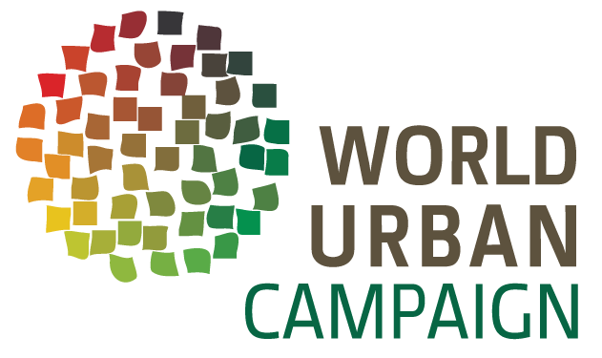
- ABOUT
- PARTNERS
- WHAT WE DO
- JOIN
- THINK
- SHARE
- ACT

INDU PRAKASH SINGH
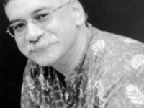
Indu Prakash Singh, a human rights defender, poet, author, a feminist and a PRA / PLA (Participatory Reflection & Action / Participatory Learning & Action / Participatory Rural Appraisal) practitioner / facilitator, is currently the Leader of Urban Knowledge Activist Hub / Citizens' Rights Collective (CiRiC), ActionAid, India.
Social Media: LinkedIn, Facebook News: Global Press Journal - Indu Prakash Singh
AN EXHORTATION TO BUILD A MOVEMENT TO END HOMELESSNESS GLOBALLY
A caring city is more important, than it being smart! If it’s only smart; it’s heartless, hopeless…
It's possible and we shall do it.
We surely will put our minds and hearts together to give our work a push, globally. For I see all the activists, globally as animated and as committed, as we all are.
The “CityMakers” (homeless residents) in India, the “CityMakers” in the world are not prepared any longer to waste their lives to addiction, police brutality and death due to the vagaries of nature or death at the hands of mowing cars of Salman Khan (http://www.bollywoodlife.com/news-gossip/indu-prakash-singh-calls-for-boycott-of-sonakshi-sinha-varun-dhawan-and-arjun-kapoors-films-for-supporting-salman-khan-in-the-hit-and-run-case/), or other elite or other drunk drivers or the gargantuan bureaucratic insolence, indolence, indifference and arrogance.
The “CityMakers” see a hope and we are part of this hope. We are unstoppable and shall relentlessly pursue the dream of a home for all. A similar dream of which Martin Luther King Junior spoke of in the 1950s - a dream, that our freedom fighters saw in 1857, and made it a reality in 1947. We can't waste the world and India, into the hands of few rich to exploit our nations and the countries world over. It's our world too. And we can't rest until we have ushered equity, justice, dignity, prosperity, faith and love for all. It's our universe. And we have to have all this in our lifetime. We can't fritter away our hope and this great opportunity.
ActionAid in India has launched the People's Vision of the City (PVoC), as an attempt to address the urgent need to design and plan equitable and sustainable cities. It is a methodology to develop consensus and plans based on the aspirations and needs of the citizens, especially the most vulnerable, in order to build an imagination of an equitable and sustainable city in which they wish to live. It involves outreach, dialogue, research, campaigning and knowledge-creation on a vast scale in the cities which choose to be part of this programme." (PVoC Handbook, p.36.) The World Urban Campaign offers us the opportunity to have many PVoCs, or rather PVoCs on a scale, leading it to impact globally. At ActionAid, we, along with our partners have unleashed an intervention called People Dependent on Informal Economy (PIE) in the area of labor, labor rights, and collectivization of the workers in the informal sector, livelihoods, skill building and enhancement, and an Urban Action School to bridge the gap between activism, academia, bureaucracy and policy formulation.
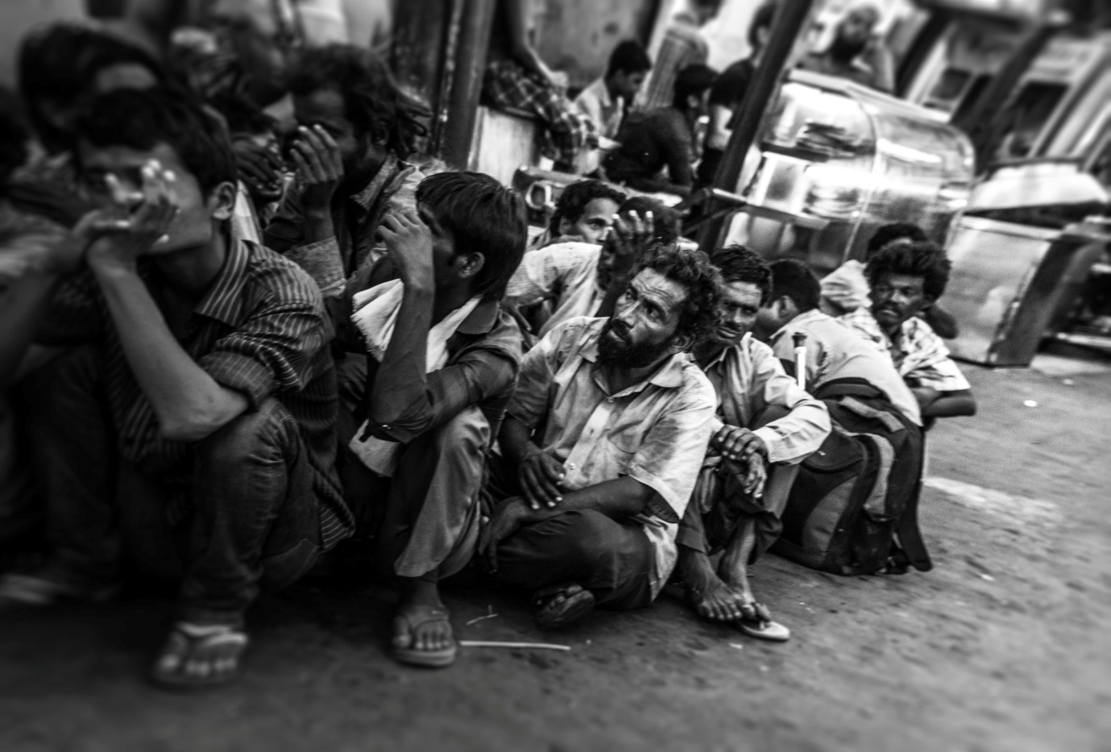

[KIRAN BABU / NIUA PHOTO CONTEST]
Time has come when a holistic approach is the key to any urban development. If its growth oriented without equity, dignity, and justice then that paradigm of growth will be a burden to any economy with mushrooming poverty; and the elite moving into the gated communities of the “super-rich” with a gaping and perforated sense of community. Such a model can never be sustainable. The SDGs need to really spawn sustainable processes. Mere terms like smart cities, shining cities, will not make any city vibrant, until and unless all the stakeholders own the process of the development of cities and model it according to their collective dreams. We need caring cities. More collaborative, than competitive cities, accessible to all, instead of gated for a few.
The idea of Caring and Sustainable Cities presume that the following will be deeply valued, respected and adhered to: CityMakers (homeless residents) have a right to the city; as per the norms of Master Plan for Delhi, 2021 (MPD, 2021), for the shelters for the homeless (CityMakers), extended over the country by the Hon’ble Supreme Court of India (WP (C) 196 / 2001 and WP (C) 55 &572 / 2003), there has to be 24X7X365 days shelters to the tune of 1 shelter per 100,000 (Clause 4.3; MPD 2021) urban population. Each permanent shelter has a size of 1000 Sq. m. dimension (Clause 4.4.3 F; MPD 2021) - incorporating the National Urban Livelihood Mission’s (NULM) 2014 provisions per person space provision in shelters should be of 50 Sq. ft.; the shelters for the CityMakers (homeless residents) have to be in the nature of: Children’s shelters, Women’s shelters, Family shelters, Men’s shelters, recovery shelters (for the ill and ailing homeless to recover after hospitalization) and shelters for de-addiction. All this will be open to elderly and the disabled too. Except men, who are gainfully employed, who can pay nominal charges for their stay, all the shelters will be free of charge with amenities like drinking water, toilets, fans etc.
The idea of caring and sustainable cities mandate: indivisibility of all rights. All rights are of primacy: housing, health, food, work (livelihoods), drinking water, sanitation, education. Nothing can wait, all have to be there at the same time; care for each other: 24X7X365. The idea of caring and sustainable cities necessitate: all having homes or places to sleep. Housing rights for everyone, today and now, not in 2022. Instead of sleeping on footpaths and getting beaten by police, run over by vehicles, falling sick and getting added to the ever increasing numbers of unidentified dead bodies; no one sleeping hungry; all having undisturbed sleep at night; no cut-off dates; no evictions; no poverty; none with addictions and chemical dependence; in situ up gradations; good accessible hospitals; accountable governance; humane bureaucracy; helpful police; just judiciary; responsive media; responsible citizens: youth, and retired; inclusive authorities; competent and corruption-free Municipalities.
The idea of Caring and Sustainable Cities need to ensure: ENGAGING - Academia, Accountable People’s representatives (MPs, MLAs, and Councilors) - Committed professionals: advocates, doctors, healers, corporates, engineers, fashion designers. Well networked activists: committed and dedicated; deep spiritual practitioners, beyond ossified religious practices and institutions: praying and doing well for all, not just for their believers.
The idea of Caring and Sustainable Cities inheres, in the spirit of “all for all”, with all, by all, to all.
UN-HABITAT and the World Urban Campaign (WUC) are great opportunities to globally right the wrongs. Mere slogans will not deliver. We will need to act, collectively, as one world - with everyone at peace and not in shambles and pieces. We need urban societies in sync with any other society, rural, tribal, coastal, hilly etc.
We need to build a world community of sharing our strategies, ideas, actions and campaigns.
Over to Our Movement to End Homelessness Globally!
http://www.urbangateway.org/wuc/indu-prakash-singh

