United Nations Conference on Housing and

Sustainable Urban Development ‐ Habitat III

Issue Paper 11: Public Space 29th May 2015

- Key words: socially inclusive, gender inclusive, integrated, productive, connected, environmentally sustainable, resilient, urban safety, value sharing, place-making.

- Key concepts:

- Public space – Public spaces are all places publicly owned or of public use, accessible and enjoyable by all for free and without profit motive. This includes streets, open spaces and public facilities.
- Urban commons – commons were traditionally defined as elements of the environment – forests, atmosphere, rivers, fisheries or grazing land – that were shared, used and enjoyed by all. Today, the commons also include public goods, such as public space, marketplaces, public education, health and infrastructure that allow society to function.
- Placemaking – Placemaking refers to a collaborative process of shaping the public realm in order to maximize shared value. More than promoting better urban design, placemaking facilitates use, paying particular attention to the physical, cultural, and social identities that define a place.
- Walkability - The extent to which the built environment is friendly to people moving on foot in an area. Factors affecting walkability include, but are not limited to: street connectivity; land-use mix; residential density; presence of trees and vegetation; frequency and variety of buildings, entrances and other sensations along street frontages.
- Equality - involves systematic (re)distribution of the benefits of growth or development, with legal frameworks ensuring a ‘level playing field’ and institutions protecting the rights of the poor, minorities and vulnerable groups.
- Community space - common space goes beyond public or private spaces.
- Housing - Connection with Housing is rather weak, which is regrettable, since Habitat II was about housing.
- Mitigation – Develop explanation on the mitigation capabilities of public space to climate change.

- Key facts and figures

There is growing attention to public space. In 2011, at the 23rd Session of the Governing Council of UN-Habitat, member states mandated UN-Habitat to consolidate agency-wide work on public space, to develop and promote public space policy, coordination, disseminate knowledge and directly assist cities in public space initiatives. The UN’s Open Working Group charged with drafting the 2016-2030 Sustainable Development Goals has proposed an eleventh Goal 11 ‘Build cities and human settlements inclusive, safe, resilient and sustainable.’ One of the proposed targets set out is “by 2030, provide universal access to safe, inclusive and accessible, green and public spaces, particularly for women and children, older persons and persons with disabilities”.

Against this backdrop, in a global sample of 120 cities, the sum of all urban areas that are not covered by impervious surfaces was estimated between 30 per cent to almost half.

Out of the 40 cities studied, only 7 allocated more than 20% of land to streets in their city core, and less than 10% in their suburban areas. In Europe and North America the cores of cities have 25% of land allocated to streets, whilst suburban areas have less than 15%. In most city cores of the developing world, less than 15% of land is allocated to streets and the situation is even worse in the suburbs and informal settlements where less than 10% of land is allocated to street. This is a reflection of the huge inequalities in many cities of the developing world.

From 1980–2000, total recorded crime rates in the world increased by about 30% and it is estimated that about 15% of those crimes have a public space design and management component. This has resulted in a growth of gated communities, sealed off by walls and sophisticated security installations, have emerged in nearly all Latin American and African cities.

Over the last 30 years, public spaces are becoming highly commercialized and have been replaced by private or semi-public buildings. Commercialization divides society and eventually separates people into different social classes.

4. Issue Summary

The character of a city is defined by its streets and public spaces. From squares and boulevards to neighbourhood gardens and children playgrounds, public space frames city image. The connective matrix of streets and public spaces forms the skeleton of the city upon which all else rests. Public space takes many spatial forms, including parks, the streets, sidewalks and footpaths that connect, playgrounds of recreation, marketplaces, but also edge space between buildings or roadsides which are often important spaces for the urban poor and in many contexts beaches are also public spaces. This does not mean that all public spaces are “open spaces” – a library, a school or other public facilities are also public spaces. Public space forms the setting for a panoply of activities - the ceremonial festivities of the multi-cultural city, trade of the commercial city, the movement of goods and people, provision of infrastructure, or the setting for community life and livelihoods of the urban poor – e.g. street vendors or waste-pickers.

Public space generates equality. Where public space is inadequate, poorly designed, or privatized, the city becomes increasingly segregated. Lines are drawn based on religion, ethnicity, gender and economic status because people don’t meet or get to know each other. The result can be a polarized city where social tensions are likely to flare up and where social mobility and economic opportunity are stifled. Adequate planning and designing public spaces raise issues regarding the right of people to freedom of artistic expression, political assembly and civic empowerment, to enjoy, engage and exchange with each.

Well-designed and maintained streets and public spaces help lower rates of crime and violence and make space for formal and informal social, cultural and economic activities that contribute to improving mutual trust and safety. Public space can be the setting for crime that creates urban ghettos and undermines good governance. In many towns and cities some public spaces are not maintained and left derelict, their vibrancy and potential lost. The challenge to maintain public spaces is the responsibility of municipalities but there is also a role for the citizens, communities and of course private sector.

A city can tackle inequality through the provision of inclusive, safe and accessible public spaces. Ensuring adequate density is important in supporting social capital formation. Local authorities sometimes ignore the use of public space by the poor, although public space is ‘the poor man’s living room’ and important for recreation, social, cultural and economic development of vulnerable groups. Public space as a common good is the key enabler for the fulfillment of human rights, empowering women and providing opportunities for youth. Improving access to and participation for the most vulnerable is a powerful tool to improve equity, promote inclusion and combat discrimination in public space. Inadequate housing should be compensated by generous provisions of good quality public space. Investments in streets and public space infrastructure improve urban productivity, livelihoods and allows better access to markets, jobs and public services, especially in developing countries where over half of the urban workforce is informal.

The public service dimension of maintaining the streets and public spaces where local authorities can work together with citizens and the private sector to manage and maintain the urban commons is important, for example the City Improvement Districts in Johannesburg, South Africa. The private sector generally fails to provide genuinely accessible public space and wider urban connectivity, so the role of local governments in defending and maintaining the commons is critical.

Public space generates substantial economic value. There is evidence that a well-planned, well-managed public space has positive impact on the price of nearby residential properties. In the Netherlands, a park view raised house prices by 8%, whilst in Berlin, proximity to playgrounds increased land value with up to 16%. Well-managed public space encourages investment confidence, e.g. business turn over in a high street location in London increases by between 5-15% following investment in a nearby public space. The increase of property value can be captured and shared as it contributes to public revenue and investment. Land value sharing requires specific instruments such as valuation, taxation or land readjustment. Focusing on streets and public spaces as a business case for urban regeneration can help cities as engines of economic and social development. Gentrification, which can improve property values, can hardly be opposed particularly when it infuses resources, regeneration and new services in the city. However, adopting redistributive policies is crucial to redirecting municipal resources generated by gentrification to improving supply, quantity and distribution of public space in less fortunate neighbourhoods.

Streets and public space as drivers of economic development. Good public spaces play a decisive role in attracting investment, uses and activities, thus enhancing safety; increasing property values, generating municipal revenue; providing opportunities for economic interaction and enhancing livelihood opportunities. A good connective matrix of public space has impact on economic productivity as it improves the efficiency of the supply chain, reducing production costs and promoting the mobility of goods and people. Public space provides important benefits to all forms of business, both formal and informal. In particular, public spaces where informal business can be carried out provide poorer urban dwellers with precious livelihood opportunities. Shared public space is important, e.g. street vendors often share space with other users taking place in the public space. The vibrancy of public space has a direct relationship with urban density, as well as mixed-use and social-mix.

Context matters. There are significant differences in public spaces across climate zones, in different cultural and social settings, and between the developed and developing world, in formal and informal parts of the city, as well as the flexible use of space by different groups of people over time. This creates very different patterns and amount of public space as shown in the image below.

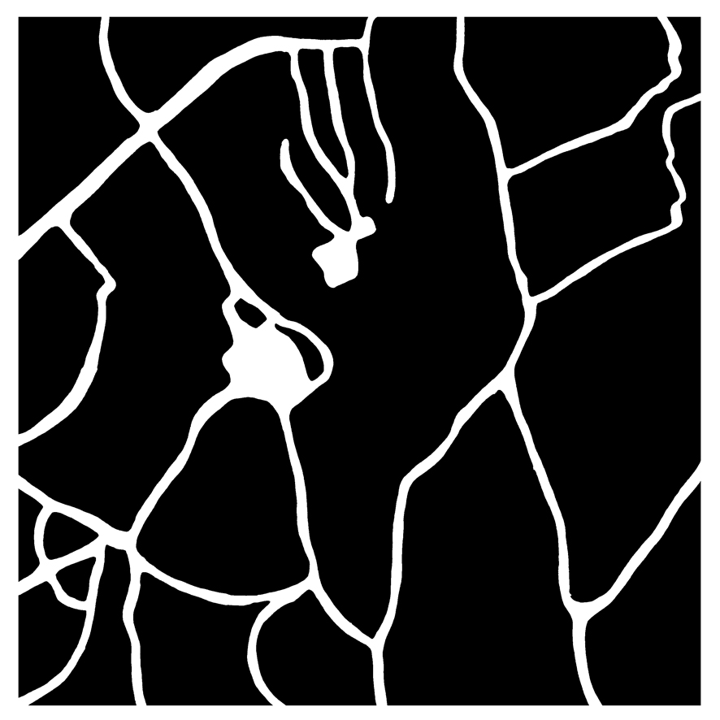
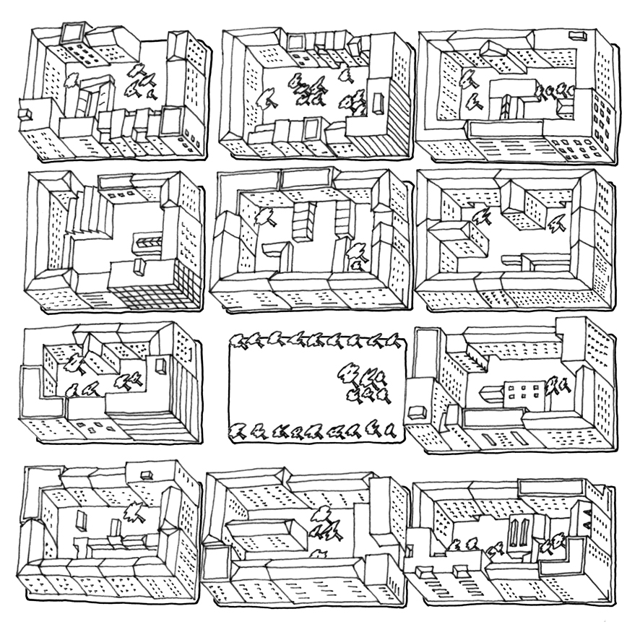
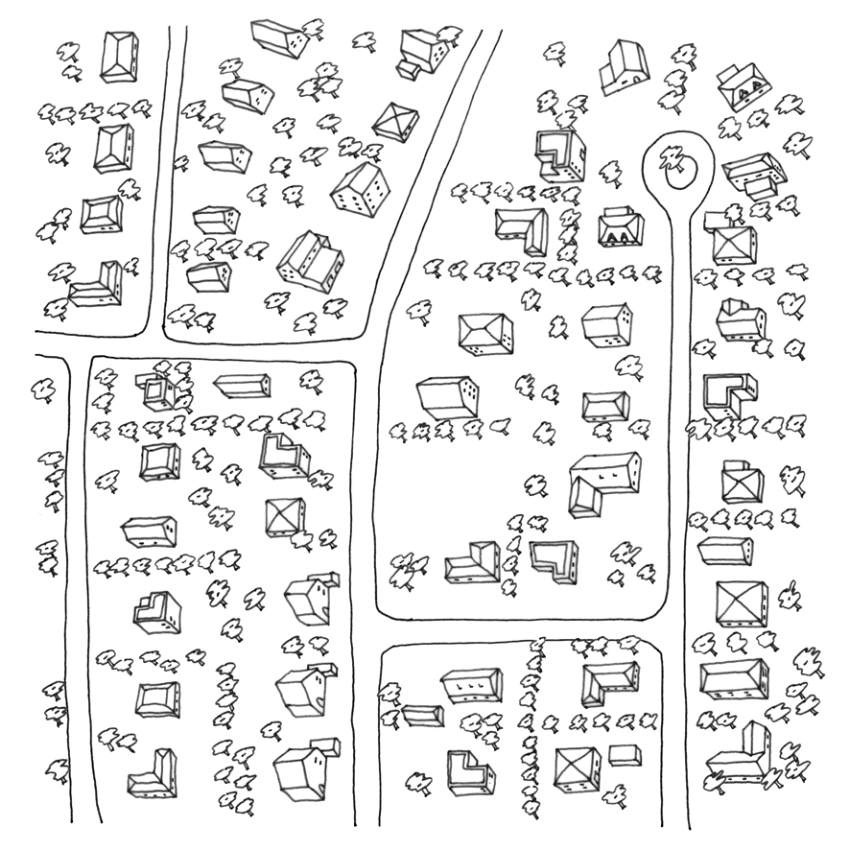
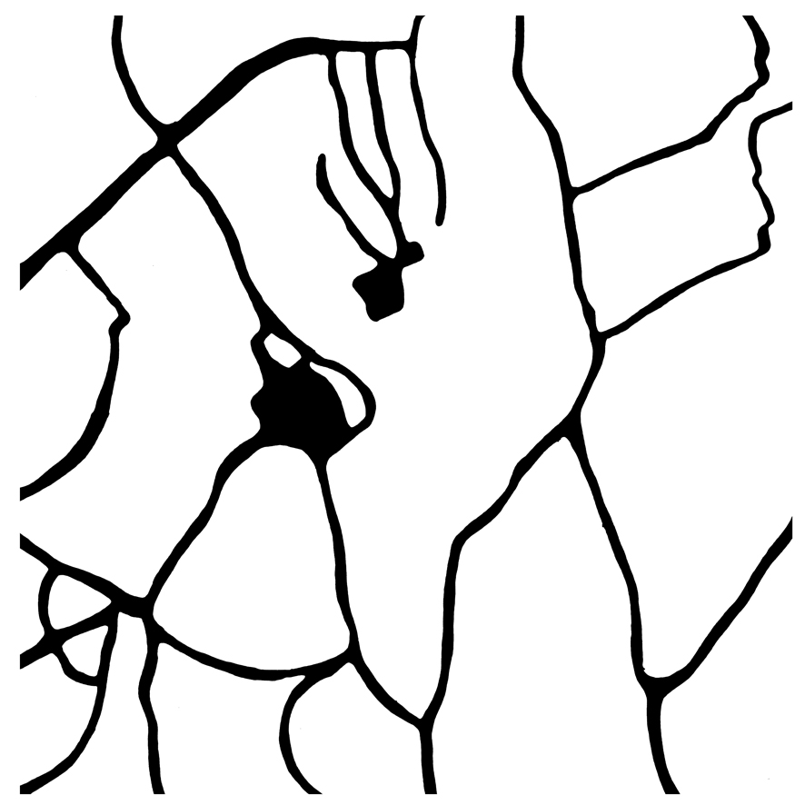
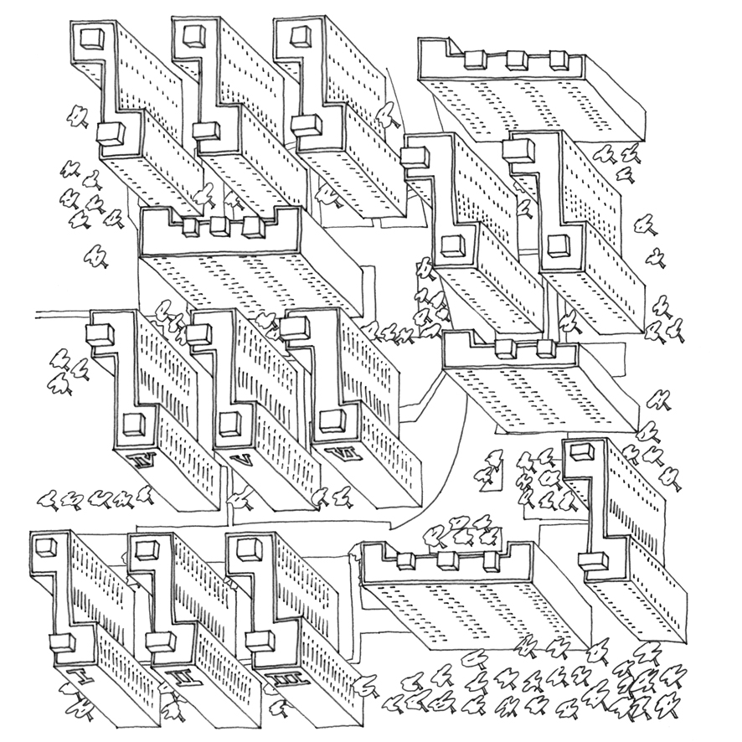
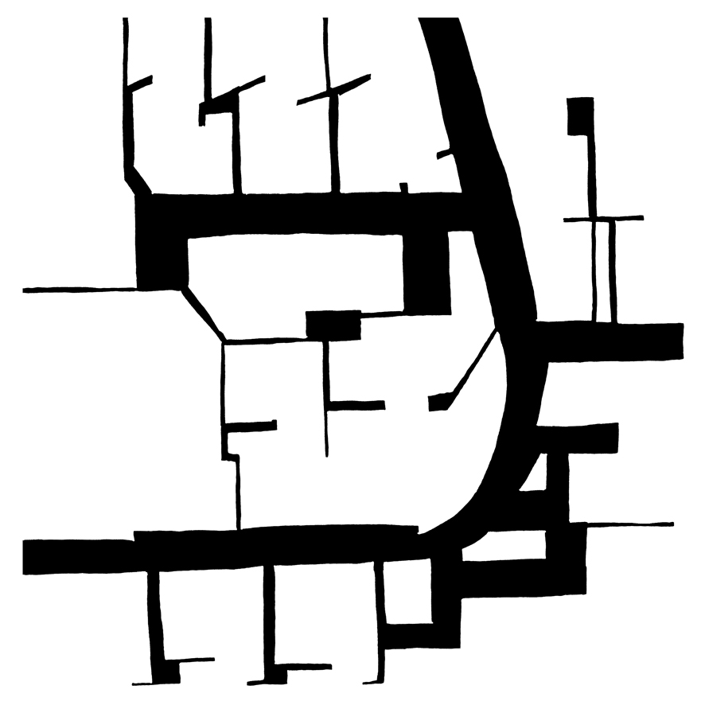

Informal settlement
Public Space: 12%
Residential Area
Public Space: 11%
Inner-city blocks
Public Space: 39%

Tower in the Park
Public Space: 13%

Public spaces must be seen as multi-functional areas for social interaction, economic exchange and cultural expression among a wide diversity of people and should be designed and managed to ensure human development, building peaceful and democratic societies and promoting cultural diversity.
Public space is critical for environmental sustainability. Adequately planned and designed public spaces play a critical role in mitigation and adaptation strategies to climate change. Green open spaces can minimise carbon emissions by absorbing carbon from the atmosphere. A 10% improvement in a street’s walking quality could yield a reduction of 15kg of CO2 emissions per household per year as car reliance reduces. Green spaces can act as sustainable drainage system, solar temperature moderator, source of cooling corridors, wind shelter and wildlife habitat. Many city governments are using planning and design to catalyse urban regeneration, create socially and culturally inclusive public places and promote greening of the city. Local and national governments are developing policies that promote compact, liveable areas, with adequate public space that facilitate public transport, encourages walking and cycling, thereby reducing carbon emissions. The compact city is the only environmentally sustainable form for a city, paying attention to groups with special needs, such as people with disabilities. Studies have demonstrated that interaction with nature, through green public space, has been associated with general and mental health. The World Health Organisation recommends a minimum of 9 square meters green space per capita and that all residents live a 15-minute walk to green space. Other studies suggest that urban ecosystem services like air pollution reduction and urban cooling have multiple long term health benefits.
Strengthening legal frameworks to protect public space. Weak legal frameworks coupled with poor policy and weak political will have resulted in grabbing of public land, the capture of benefit by private actors and conflict between communities and government over the use of public space. As urbanization proceeds, low proportions of public space are created and secured. The role of legislation, regulation and enforcement is a key mechanism to secure the provision, vitality and utility of public space for the long-term. Clear policy, that recognizes the capacity to enforce laws and regulations, is vital for making public space well managed as well as protect public space. Ideally, urban planning systems should have the requirement of adequate public space as part of local and municipal plans.

Strengthening knowledge, tools and approaches for viable public space at city level. Attention on the quantity, distribution, accessibility and quality of public space in cities has been piecemeal, especially lack of comparative data. Although some cities measure percentage of open space, there are no agreed tools or indicators for assessing either the quantity or quality of public space. There is a key role for academia and research in developing these tools and indicators for and bringing this to the fore.

Public space lends itself well to participatory approaches. Access to and participation in public space is a first step toward civic empowerment. Public space creation, protection, management and enjoyment are ideal opportunities for the involvement of all citizens, ensuring that individual and differentiated interests are transformed into collaborative practices. The quest for engagement tools in securing and maintaining public spaces has spurred the place-making concept which inspires people to collectively reimagine and reinvent public spaces and improving their neighborhoods. Public space enables the population to remain engaged and to stake a claim on the city. This implies to respect and protect a number of rights and freedoms, such as the right to freedom of expression and assembly, the right to information, consultation and participation in decision-making processes. A good city should foster social cohesion and build social capital, engaging the community in design, management and maintenance of public space. The public space interdisciplinary and participatory approaches are an opportunity for planners, landscape professionals, architects, technicians and designers to express fully their roles. However, it is important to highlight that there are competing ideas and that conflict currently occur in and around the public space.
Competing claims on availability of mixed-use public space, between for example street vendors, pedestrians and cars can be turned into proactive elements that ensure that the urban landscape is reflective of our complex societies, histories and cultural diversity. Public space reflects class, gender, age and ethnic differences in how people use streets and public spaces. Some groups, such as women, children, undocumented migrants or the poor, may be excluded from public space by violence or control. As public space is the place of conviviality and tolerance, but also of difference and conflict in use over time this sometimes requires mediation and the establishment of conflict resolution mechanisms to reconcile the differences.

City-wide policies and strategies should ensure planning, design and management of public spaces at different scales. Ensuring city-wide distribution of public spaces is a way for governments to reduce inequalities and reallocate benefits. The benefit of preparing a city-wide strategy/policy is the protection and creation of a network of high-quality public spaces. Without a clear strategy/policy, it is difficult for local governments to prioritise, spend and plan resources and to show how much public space is valued, and to mitigate the negative impacts of site specific interventions (e.g. gentrification). A strong strategic policy framework, supported by urban design, is core. Surprisingly, not all urban plans contain sufficient guidance for the creation, layout and design of public spaces.

A new paradigm is evolving to create or protect public spaces. Enabling components of the new urban agenda are rules and legislation for creating and protecting access to public spaces, urban planning and design for providing adequate quantity and good quality public space, and urban finance and economy for sharing values, promoting local economic development, providing employment and attracting investment.
Securing public space in planned city extensions, city infills and slum-upgrading as part of the urban development agenda. In many cities low proportions of public space are being created and secured. In formally developed areas it is essential to protect and enhance existing public space, to increase security, improve management and planning, and increase access; planning standards can protect public space from development and support incremental creation of new public spaces, as in Hong Kong where developers who create new pocket parks on a constrained site are permitted increased floor space in return. In informal settlements a participatory slum-upgrading approach can identify spaces where community-led intervention can improve facilities and services without major relocations, for example Slum Dwellers International re-blocking approach in Cape Town, South Africa, where paving footpaths and access routes, improving drainage and providing play spaces is enhancing the quality of life. In planned urban extensions more generous allocations can be achieved by ensuring public space allocations that are culturally and climatically appropriate.

Public space-led urban development. When planning focuses on providing adequate supply of connected public space with a view to supporting adequate density, it is possible to move forward with infrastructure, land subdivision and development in a more efficient and sustainable way. Public space can lead urban development by ensuring that building will only be permitted if public space has been organized prior to development. This link between public space and urban development needs to be understood in each context and legal framework in order to prevent the creation of unmanaged and/or public space deficiencies common to many cities. Particularly in recent decades, many cities have put public space at the core of urban development, for example Bogota in Colombia.

Public Space goal/target. UN-Habitat is proposing a set of targets for the amount of land allocated to streets and public space in urban areas to ensure adequate foundation for the city. The proposed goal/target for public space being suggested is 45% of land should be allocated to streets and public space. This can be broken down into 30% for streets and sidewalks and 15% for open spaces, green spaces and public facilities. The target for street connectivity is between 80-120 intersections per square kilometer. At an optimal level of 100 intersections per km2 with each street having an average width of 15m, a city’s streets would occupy approximately 28% of the total area. This should also be complemented by a qualitative target assessing accessibility, use and safety among other aspects.

4. Key drivers for action
- At regional and city level, city-wide strategies need to focus not only on places and spaces but on the form, function and connectivity of the city as a whole.
- Local authorities should be able to design the network of public space as part of their development plans.
- At neighbourhood level, urban design should work with communities to foster social inclusion, celebrate multiculturalism, and enable urban livelihoods, thus creating rich, vibrant spaces in the urban commons.
- Laws and regulations need to be reviewed, to establish enabling systems to create, revitalise, manage, and maintain public space, including participatory processes to define their use and manage access to public spaces.
- Land value sharing and land readjustment tools to be widely adopted and promoted for municipalities to capture private values generated by better public spaces to sustain investment in public space.
- Investing in public space needs to be harnessed as a driver for economic and social development, taking into consideration urban-rural linkages.
- As cities expand, the necessary land for streets and public spaces as well as public infrastructure networks must be secured. Urban projects need to ensure adequate public space in planned city extensions, planned city infills and participatory slum upgrading projects. Instruments to enable the creation of public space from private owned land are of critical importance.
- Debate on targets, indictors and principles on measuring the distribution, quantity, quality and accessibility of public space.

5. Existing Platforms/projects
UN-Habitat Global Programme on Public Space - works on public space, develops and promotes public space approaches, coordinates partners, disseminates knowledge and directly assists cities in developing city-wide public space strategies - http://www.urbangateway.org/publicspace
UN-Habitat Global network on Urban Planning and Design Labs - Offers services to national, regional and local governments on developing an integrated and holistic approach to urban development focusing on knowledge areas: spatial planning, legislation and governance and economy and finance. http://unhabitat.org/urban-themes/planning-and-design/
UN-Habitat Global Network on Safer Cities - is an international platform for cities and urban stakeholders endeavoring to prevent crime and improve urban safety in cities - http://unhabitat.org/global-network-on-safer-cities/
Future of Places Forum – is a collaboration between Un-Habitat, Ax:son Johnson foundation and Project for Public Spaces with the purpose to advocate for the importance of public space and placemaking in city planning - http://futureofplaces.com/about-future-of-places/

UN-Habitat Resolution 23/4 on Sustainable Urban Development through Access to Public Spaces
Angel, S. (2012), Planet of Cities (pg 208-212)
UN-Habitat (2013) Streets as Public Spaces and Drivers of Urban Prosperity. Nairobi.
UN-Habitat, Global Report on Human Settlements (2007), Enhancing Urban Safety and Security
Land Use Policy, Volume 25, Issue 2, April 2008, Pages 153–160
UN-Habitat, 2012 Placemaking and the Future of Cities
Refer to Issue Paper n. 2 on Safer Cities.
Key Messages, Future of Places Conference II, Buenos Aires 2014 - http://futureofplaces.com/2014/12/key-messages-from-buenos-aires-conference-2014/
UN-Habitat Global report on Human Settlements: Planning Sustainable Cities (2009)
UN-Habitat, 2009 Planning Sustainable Cities: Global report on Human Settlements, pp148-149
UN-Habitat city extension presentation
UN-Habitat, Urbanization For Prosperity Policy Statement, 25th Session of the Governing Council
Elmqvist, Th., Fragkias, M., Goodness, J., Güneralp, B, Editors (2013) A Global Assessment “Urbanization, Biodiversity and Ecosystem Services: Challenges and Opportunities” pg 199
Ibid
UN-Habitat ( March 2015), Report of the Seventh Session of the Word Urban Forum: Urban Equity in Development – Cities for Life
UN-Habitat 2013. Streets as Public Spaces and Drivers of Urban Prosperity. Nairobi.
defined by those achieving a minimum density of 150 inhabitants per hectare, the minimum threshold for a viable public transport system.
Ibid.
http://mirror.unhabitat.org/downloads/docs/StreetPatterns.pdf
minimum for one vehicular lane each direction, streetside parking, planting and sidewalks

